

DATA STRUCTURES
LABORATORY

LAB MANUAL

Department of Computer Engineering
Prepared by :
Prof. Rupesh Mahajan
Prof.B.S.Satpute

Dr.D.Y.Patil Institute of Technology,
Pimpri, Pune-411018

Pimpri, Pune

ASSIGNMENT LIST
Assignment No. | Name of the Assignment /Experiment
1 | In Second year Computer Engineering class of M students, set A of students play cricket and set B of students play badminton. Write C/C++ program to find and display-  i. Set of students who play either cricket or badminton or both  ii. Set of students who play both cricket and badminton  iii. Set of students who play only cricket  iv. Set of students who play only badminton  v. Number of students who play neither cricket nor badminton
2 | Write C/C++ program to store marks scored for first test of subject 'Data Structures and Algorithms' for N students. Compute  i. The average score of class  ii. Highest score and lowest score of class  iii. Marks scored by most of the students  iv. list of students who were absent for the test
3 | Set A=(1,3, a, s, t, i} represent alphanumeric characters permitted to set the password of length 4. Write C/C++ program to generate all possible passwords.
4 | A magic square is an n * n matrix of the integers 1 to n2 such that the sum of each row, column, and diagonal is the same. Write C/C++ Program for magic square.
5 | Write C/C++ program for storing matrix. Write functions for  a) Check whether given matrix is upper triangular or not  b) Compute summation of diagonal elements  c) Compute transpose of matrix  d) Add, subtract and multiply two matrices
6 | Write C++ program for string operations- copy, concatenate, check substring, equal, reverse and length
7 | Department of Computer Engineering has student's club named 'Pinnacle Club'. Students of Second, third and final year of department can be granted membership on request. Similarly one may cancel the membership of club. First node is reserved for president of club and last node is reserved for secretary of club. Write C++ program to maintain club member‘s information using singly linked list. Store student PRN and Name. Write functions to  a) Add and delete the members as well as president or even secretary.  b) Compute total number of members of club  c) Display members  d) Display list in reverse order using recursion  e) Two linked lists exists for two divisions. Concatenate two lists.
8 | Second year Computer Engineering class, set A of students like Vanilla Ice-cream and set B of students like butterscotch ice-cream. Write C/C++ program to store two sets using linked list. compute and display-  i. Set of students who like either vanilla or butterscotch or both  ii. Set of students who like both vanilla and butterscotch  iii. Set of students who like only vanilla not butterscotch  iv. Set of students who like only butterscotch not vanilla  v. Number of students who like neither vanilla nor butterscotch
9 | Write C++ program to store set of negative and positive numbers using linked list. Write functions  a) Insert numbers  b) Delete nodes with negative numbers  c) To create two more linked lists using this list, one containing all positive numbers and other containing negative numbers  d) For two lists that are sorted; Merge these two lists into third resultant list that is sorted
10 | Write C++ program for storing binary number using doubly linked lists. Write functions  a) to compute 1‘s and 2‘s complement  b) add two binary numbers
11 | Implement C++ program for expression conversion-  a) infix to prefix, b)prefix to postfix,  c) prefix to infix, d) postfix to infix and e) postfix to prefix.
12 | A classic problem that can be solved by backtracking is called the Eight Queens problem, which comes from the game of chess. The chess board consist of 64 square arranged in an 8 by 8 grid. The board normally alternates between black and white square, but this is not relevant for the present problem. The queen can move as far as she wants in any direction, as long as she follows a straight line, Vertically, horizontally, or diagonally. Write C++ program with recursive function for generating all possible configurations for 4-queen's problem.
13 | Write program to implement a priority queue in C++ using an inorder List to store the items in the queue. Create a class that includes the data items(which should be template) and the priority (which should be int)The inorder list should contain these objects ,with operator <= overloaded so that the items with highest priority appear at the beginning of the list (which will make it relatively easy to retrieve the highest item.)
14 | Pizza parlor accepting maximum M orders. Orders are served in first come first served basis. Order once placed cannot be cancelled. Write C++ program to simulate the system using circular queue using array.
15 | a) Write C++ program to store roll numbers of student in array who attended training program in random order. Write function for searching whether particular student attended training program or not using linear search and sentinel search.  b) Write C++ program to store roll numbers of student array who attended training program in sorted order. Write function for searching whether particular student attended training program or not using binary search and Fibonacci search.
16 | a) Write C++ program to store names and mobile numbers of your friends in sorted order on names. Search your friend from list using binary search (recursive and non recursive). Insert friend if not present in phonebook.  b) Write C++ program to store names and mobile numbers of your friends in sorted order on names. Search your friend from list using Fibonacci search. Insert friend if not present in phonebook.
17 -A | Write C++ program to store first year percentage of students in array. Write function for sorting array of floating point numbers in ascending order using  a) Selection Sort  b) Bubble sort and display top five scores.
17 –B | Write C++ program to store second year percentage of students in array. Write function for sorting array of floating point numbers in ascending order using  a) Insertion sort  b) Shell Sort and display top five scores.
17 –C | Write C++ program to store first year percentage of students in array. Write function for sorting array of floating point numbers in ascending order using quick sort and display top five scores.
17 –D | Write C++ program to store XIIth percentage of students in array. Write function for sorting array of floating point numbers in ascending order using bucket sort and display top five scores..
17 -E | Write C++ program to store Xth percentage of students in array. Write function for sorting array of floating point numbers in ascending order using radix sort and display top five scores.

Course Objectives

1. Effective use of Object Oriented Programming concepts in data structures and files in programming.
2. Effective use of multi-core programming architecture in programming.
3. Effective use of latest programming tools like Eclipse Programming Framework, Microsoft Visual Studio, TC++, QT/ Java/Python etc

Mapping Of Subjects With Cos and Pos
Course Name | Course Outcome | a | b | c | d | e | f | g | h | i | j | k | l
SE- 2015  Data Structure  Lab | - Effective use of Object Oriented Programming concepts in data structures and files in programming. | 2 | 2 | 2 | 1 |  |  |  |  |  |  | 1 | 1
SE- 2015  Data Structure  Lab | - Effective use of multi-core programming architecture in programming. | 2 | 1 | 2 | 1 |  | 2 |  |  |  |  | 1 | 1
SE- 2015  Data Structure  Lab | - Effective use of latest programming tools like  Eclipse Programming Framework, Microsoft Visual Studio, TC++, QT/ Java/Python etc | 2 | 2 | 2 | 2 | 2 | 1 |  |  |  | 1 | 2 | 2

Mapping Of Assignments to Cos and Pos
Sr No | Name of the Assignment /Experiment | Course Outcomes achieved | PEO,s achieved
1 | In Second year Computer Engineering class of M students, set A of students play cricket and set B of students play badminton. Write C/C++ program to find and display-  i. Set of students who play either cricket or badminton or both  ii. Set of students who play both cricket and badminton  iii. Set of students who play only cricket  iv. Set of students who play only badminton  v. Number of students who play neither cricket nor badminton | 1,2,3 | a,b,c,d,e
2 | Write C/C++ program to store marks scored for first test of subject 'Data Structures and Algorithms' for N students. Compute  i. The average score of class  ii. Highest score and lowest score of class  iii. Marks scored by most of the students  iv. list of students who were absent for the test | 1,3 | b,c,d,e
3 | Set A=(1,3, a, s, t, i} represent alphanumeric characters permitted to set the password of length 4. Write C/C++ program to generate all possible passwords. | 1,2,3 | a,b,c,d,e
4 | A magic square is an n * n matrix of the integers 1 to n2 such that the sum of each row, column, and diagonal is the same. Write C/C++ Program for magic square. | 1,3 | b,c,d,e,j
5 | Write C/C++ program for storing matrix. Write functions for  a) Check whether given matrix is upper triangular or not  b) Compute summation of diagonal elements  c) Compute transpose of matrix  d) Add, subtract and multiply two matrices | 1,3 | b,c,d,e,j
6 | Write C++ program for string operations- copy, concatenate, check substring, equal, reverse and length | 1,2,3 | b,c,d,e
7 | Department of Computer Engineering has student's club named 'Pinnacle Club'. Students of Second, third and final year of department can be granted membership on request. Similarly one may cancel the membership of club. First node is reserved for president of club and last node is reserved for secretary of club. Write C++ program to maintain club member‘s information using singly linked list. Store student PRN and Name. Write functions to  a) Add and delete the members as well as president or even secretary.  b) Compute total number of members of club  c) Display members  d) Display list in reverse order using recursion  e) Two linked lists exists for two divisions. Concatenate two lists. | 1,3 | a,b,c,d,e
8 | Second year Computer Engineering class, set A of students like Vanilla Ice-cream and set B of students like butterscotch ice-cream. Write C/C++ program to store two sets using linked list. compute and display-  i. Set of students who like either vanilla or butterscotch or both  ii. Set of students who like both vanilla and butterscotch  iii. Set of students who like only vanilla not butterscotch  iv. Set of students who like only butterscotch not vanilla  v. Number of students who like neither vanilla nor butterscotch | 1,3 | a,b,c,d,e
9 | Write C++ program to store set of negative and positive numbers using linked list. Write functions  a) Insert numbers  b) Delete nodes with negative numbers  c) To create two more linked lists using this list, one containing all positive numbers and other containing negative numbers  d) For two lists that are sorted; Merge these two lists into third resultant list that is sorted | 1,3 | b,c,d,e
10 | Write C++ program for storing binary number using doubly linked lists. Write functions  a) to compute 1‘s and 2‘s complement  b) add two binary numbers | 1,3 | a,b,c,d,e
11 | Implement C++ program for expression conversion-  a) infix to prefix, b)prefix to postfix,  c) prefix to infix, d) postfix to infix and e) postfix to prefix. | 1,3 | a,b,c,d,e
12 | A classic problem that can be solved by backtracking is called the Eight Queens problem, which comes from the game of chess. The chess board consist of 64 square arranged in an 8 by 8 grid. The board normally alternates between black and white square, but this is not relevant for the present problem. The queen can move as far as she wants in any direction, as long as she follows a straight line, Vertically, horizontally, or diagonally. Write C++ program with recursive function for generating all possible configurations for 4-queen's problem. | 1,2,3 | a,b,c,d,e
13 | Write program to implement a priority queue in C++ using an inorder List to store the items in the queue. Create a class that includes the data items(which should be template) and the priority (which should be int)The inorder list should contain these objects ,with operator <= overloaded so that the items with highest priority appear at the beginning of the list (which will make it relatively easy to retrieve the highest item.) | 1,2,3 | a,b,c,d,e,j
14 | Pizza parlor accepting maximum M orders. Orders are served in first come first served basis. Order once placed can not be cancelled. Write C++ program to simulate the system using circular queue using array. | 1,2,3 | b,c,d,e
15 | a) Write C++ program to store roll numbers of student in array who attended training program in random order. Write function for searching whether particular student attended training program or not using linear search and sentinel search.  b) Write C++ program to store roll numbers of student array who attended training program in sorted order. Write function for searching whether particular student attended training program or not using binary search and Fibonacci search. | 1,2,3 | a,b,c,d,e
16 | a) Write C++ program to store names and mobile numbers of your friends in sorted order on names. Search your friend from list using binary search (recursive and non recursive). Insert friend if not present in phonebook.  b) Write C++ program to store names and mobile numbers of your friends in sorted order on names. Search your friend from list using Fibonacci search. Insert friend if not present in phonebook. | 1,2,3 | b,c,d,e
17 -A | Write C++ program to store first year percentage of students in array. Write function for sorting array of floating point numbers in ascending order using  a) Selection Sort  b) Bubble sort and display top five scores. | 1,3 | b,c,d,e,j
17 –B | Write C++ program to store second year percentage of students in array. Write function for sorting array of floating point numbers in ascending order using  a) Insertion sort  b) Shell Sort and display top five scores. | 1,3 | b,c,d,e,j
17 –C | Write C++ program to store first year percentage of students in array. Write function for sorting array of floating point numbers in ascending order using quick sort and display top five scores. | 1,3 | b,c,d,e,j
17 –D | Write C++ program to store XIIth percentage of students in array. Write function for sorting array of floating point numbers in ascending order using bucket sort and display top five scores.. | 1,3 | b,c,d,e,j
17 -E | Write C++ program to store Xth percentage of students in array. Write function for sorting array of floating point numbers in ascending order using radix sort and display top five scores. | 1,3 | b,c,d,e,j

Assignment No. 1

Problem Statement:

In Second year Computer Engineering class of M students, set A of students play cricket and set B of students play badminton. Write C/C++ program to find and display-
i. Set of students who play either cricket or badminton or both
ii. Set of students who play both cricket and badminton
iii. Set of students who play only cricket
iv. Set of students who play only badminton
v. Number of students who play neither cricket nor badminton

Theory

Set-:
Set is a collection of elements.
The term class is used to denote set.
A set may contain finite or infinite no. of elements.

Empty set-: a set is called as empty set if it contains no element denoted by ᶲ.
Universal set-: if all the set,subset of given set then this set is called as universal set denoted by U.
Subset-: if every element of set A is an element of set B, then we say that A subset of B.
Equality-> Two sets are said to be equal if they are subset of each other.

Operations of set-:
- Union
- Intersectionᶲ
- Difference
- Complement
- Cartesian product

- Union- union of 2 sets A&B is the set containing all elements which are in A or B or in both sets.
e.g. A={1,2,3} and B={4,2,5} AUB={1,2,3,4,5}

- Intersection-> it is the common elements between set A and Set B.
e.g A∩B={2}
- Difference ->
Let A and B be 2 sets then A-B is defined as
A-B={x/x € A and x € B}
E.g. A-B={1,3}
- Complement- set containing all elements of universal set excepting its own elements.
e.g. A={1,2,3}
A_{c}= U-{1,2,3}
- Cartesian product- it is the set whose members are all +ve ordered pair(a,b), where a is member and b is member of B.
e.g.- a={a,b,c}
b={a,b}
aXb={(a,a),(a,b),(b,a),(b,b),(c,a),(c,b)}
Algebra of sets-:
1. Associative law-
(a)AUB=AU(BUC)
(b)A∩B∩C=A∩(B∩C)
2. Commutative laws-:
(a) AUB=BUA
(b)A∩B=B∩A
3. Distributive law
(a) AU(B∩C)=(AUB)∩(ΑUC)

4. Independent laws-:
(a) AUB=A
(b) A∩A=A
5. Identity laws-:
(a) AU∅=A
(b) A∩U=A
(c) AUU=U
(d) A∩∅=∅
6. Complement laws-:
(a) AUA_{C}=U
(b) A∩A_{c}=∅
7. Absorption laws-:
(a)AU(A∩B)=A
(b) A∩(AU∅)=A
8.Involution law-:
A_{c}=A
9. Demorgans law-:
(a) (AUB)_{c}=AcUB_{c}
(b)(A∩V)_{c}=AcUB_{c}

Conclusion: we implemented set assignment successfully.

Assignment No. 2

Problem Statement:

Write C/C++ program to store marks scored for first test of subject 'Data Structures and Algorithms' for N students. Compute
i. The average score of class
ii. Highest score and lowest score of class
iii. Marks scored by most of the students
iv. List of students who were absent for the test

Introduction
Algorithm is a sequence of unambiguous instruction for solving a problem.
It is procedure of formula for solving a problem.
It is written in simple English.
It should be unique and self-explanatory.

Characteristic
- Precision: Steps are precisely defined.
- Uniqueness: Results of each folder are uniquely defined.
- Finiteness: Algorithm stops after finite number of steps.
- Input: Algorithm receives input.
- Output: Algorithm produces proper output.
- Generality: Algorithm applies is set input.

Complexity of an Algorithm
Complexity of an algorithm is a measure of amount of time and space required by it. For input of given size ‘n’ we define complexity as a numerical function. T(n)- Time vs. input size.

Time Complexities
It is total time required by algorithm to run for completion. It is expressed in big0 notation.

Space Complexities
Amount of computer memory required during program execution as a function of input size. There are 3 scenarios:

- Best case: Least amount of time.

- Worst Case: Maximum amount of time.

- Average Case: Average amount of time.

Introduction to Data Structure
Data structure is a specified format for organizing and storing data. It includes array, files, records, tables, trees and so on.

Types of Data Structure

- Linear
Elements are organized sequentially.

- Non Linear
Data Elements can be attached to several other elements. Example- Tree, graph.

- Static
The size of structure is fixed. Storing and performing operations is easy.

- Dynamic
Size of structure is not defined. Difficult for storing or performing operation. Memory is allocated at execution time.

Conclusion
Hence, we have studied the concept of data structure and algorithm.

Assignment No. 3

Problem Statement:

Set A=(1,3, a, s, t, i} represent alphanumeric characters permitted to set the password of length 4. Write C/C++ program to generate all possible passwords.

SOFTWARE REQUIRED: Linux Operating Systems, GCC, Eclipse framework, VC++.
MATHEMATICAL MODEL:

Let S be the solution perspective of the class strng such that
S=fi, o, f,Op ,DD, NDD, success, failureg
i= finput of the system.g
o=foutput of the system.g
f= ffunctionsg
Op=foperatorsg
DD-deterministic data it helps identifying the load store functions or assignment
functions.
NDD- Non deterministic data of the system S to be solved.
Success-desired outcome generated.
Failure-Desired outcome not generated or forced exit due to system error. For
class char:
i=f any char g,
f=getdata()
getdata()=accepts characters
Success- desired output is generated as result of particular operation
Failure- desired output is generated as successful result of particular operation

THEORY:
Permutations:
A permutation is an arrangement of all or part of a set of objects, with regard to the order of the arrangement.

For example, suppose we have a set of three letters: A, B, and C. We might ask how many ways we can arrange 2 letters from that set. Each possible arrangement would be an example of a permutation. The complete list of possible permutations would be: AB, AC, BA, BC, CA, and CB.

When they refer to permutations, statisticians use a specific terminology. They describe permutations as n distinct objects taken r at a time. Translation: n refers to the number of objects from which the permutation is formed; and r refers to the number of objects used to form the permutation. Consider the example from the previous paragraph. The permutation was formed from 3 letters (A, B, and C), so n = 3; and the permutation consisted of 2 letters, so r = 2.

Computing the number of permutations. The number of permutations of n objects taken r at a time is
nPr = n(n - 1)(n - 2) ... (n - r + 1) = n! / (n - r)!
Note the distinction between a permutation and a combination . A combination focuses on the selection of objects without regard to the order in which they are selected. A permutation, in contrast, focuses on the arrangement of objects with regard to the order in which they are arranged. Thus, the letters AB and BA represent two different permutations, because the order is different. However, they represent only 1 combination; because order is not important in a combination.
We picked certain people to win, but the details don’t matter: we had 8 choices at first, then 7, then 6. The total number of options was 8 · 7 · 6 = 336.

Let’s look at the details. We had to order 3 people out of 8. To do this, we started with all options (8) then took them away one at a time (7, then 6) until we ran out of medals.

We know the factorial is:
8!=8.7.6.5.4.3.2.1
Unfortunately, that does too much! We only want 8 · 7 · 6. How can we “stop” the factorial at 5?

This is where permutations get cool: notice how we want to get rid of 5 · 4 · 3 · 2 · 1. What’s another name for this? 5 factorial!

So, if we do 8!/5! we get:
8!/5!=(8.7.6.5.4.3.2.1)/(5.4.3.2.1)=8.7.6
And why did we use the number 5? Because it was left over after we picked 3 medals from 8. So, a better way to write this would be:

8!/(8-3)!
where 8!/(8-3)! is just a fancy way of saying “Use the first 3 numbers of 8!”. If we have n items total and want to pick k in a certain order, we get:

n!/(n-k)!
And this is the fancy permutation formula: You have n items and want to find the number of ways k items can be ordered:
P(n,k)=n!/(n-k)!

Combination:
A combination is a selection of all or part of a set of objects, without regard to the order in which objects are selected.

For example, suppose we have a set of three letters: A, B, and C. We might ask how many ways we can select 2 letters from that set. Each possible selection would be an example of a combination. The complete list of possible selections would be: AB, AC, and BC.

Computing the number of combinations. The number of Combinations of n objects taken r at a time is
nCr = n(n - 1)(n - 2) ... (n - r + 1)/r! = n! / r!(n - r)! = nPr / r!
Note that AB and BA are considered to be one combination, because the order in which objects are selected does not matter. This is the key distinction between a combination and a permutation. A combination focuses on the selection of objects without regard to the order in which they are selected. A permutation, in contrast, focuses on the arrangement of objects with regard to the order in which they are arranged.
Here’s a few examples of combinations (order doesn’t matter) from permutations (order matters).

Combination: Picking a team of 3 people from a group of 10. C(10,3) = 10!/(7! · 3!) = 10 · 9 · 8 / (3 · 2 · 1) = 120.

Permutation: Picking a President, VP and Waterboy from a group of 10. P(10,3) = 10!/7! = 10 · 9 · 8 = 720.

Combination: Choosing 3 desserts from a menu of 10. C(10,3) = 120.

Permutation: Listing your 3 favorite desserts, in order, from a menu of 10. P(10,3) = 720.

CONCLUSION:
Hence, we have studied concept of permutations and combinations and implemented it successfully

Assignment No. 4

Problem Statement:
A magic square is an n * n matrix of the integers 1 to n2 such that the sum of each row, column, and diagonal is the same. Write C/C++ Program for magic square.

Theory
Magic Square
A magic square of order n is an arrangement of n^2 numbers, usually distinct integers, in a square, such that the n numbers in all rows, all columns, and both diagonals sum to the same constant. A magic square contains the integers from 1 to n^2.
The constant sum in every row, column and diagonal is called the magic constant or magic sum, M. The magic constant of a normal magic square depends only on n and has the following value:
M = n(n^2+1)/2
For normal magic squares of order n = 3, 4, 5, …, the magic constants are: 15, 34, 65, 111, 175, 260, …
In this post, we will discuss how programmatically we can generate a magic square of size n. Before we go further, consider the below examples:
Magic Square of size 3
-----------------------
2 7 6
9 5 1
4 3 8
Sum in each row & each column = 3*(3^2+1)/2 = 15

Magic Square of size 5
----------------------
9 3 22 16 15
2 21 20 14 8
25 19 13 7 1
18 12 6 5 24
11 10 4 23 17
Sum in each row & each column = 5*(5^2+1)/2 = 65

Magic Square of size 7
----------------------
20 12 4 45 37 29 28
11 3 44 36 35 27 19
2 43 42 34 26 18 10
49 41 33 25 17 9 1
40 32 24 16 8 7 48
31 23 15 14 6 47 39
22 21 13 5 46 38 30
Sum in each row & each column = 7*(7^2+1)/2 = 175
In any magic square, the first number i.e. 1 is stored at position (n/2, n-1). Let this position be (i,j). The next number is stored at position (i-1, j+1) where we can consider each row & column as circular array i.e. they wrap around.

Three conditions hold:
1. The position of next number is calculated by decrementing row number of previous number by 1, and incrementing the column number of previous number by 1. At any time, if the calculated row position becomes -1, it will wrap around to n-1. Similarly, if the calculated column position becomes n, it will wrap around to 0.

2. If the magic square already contains a number at the calculated position, calculated column position will be decremented by 2, and calculated row position will be incremented by 1.
3. If the calculated row position is -1 & calculated column position is n, the new position would be: (0, n-2).
Example:
Magic Square of size 3
----------------------
2 7 6
9 5 1
4 3 8

Steps:
1. position of number 1 = (3/2, 3-1) = (1, 2)
2. position of number 2 = (1-1, 2+1) = (0, 0)
3. position of number 3 = (0-1, 0+1) = (3-1, 1) = (2, 1)
4. position of number 4 = (2-1, 1+1) = (1, 2)
Since, at this position, 1 is there. So, apply condition 2.
new position=(1+1,2-2)=(2,0)
5. position of number 5=(2-1,0+1)=(1,1)
6. position of number 6=(1-1,1+1)=(0,2)
7. position of number 7 = (0-1, 2+1) = (-1,3) // this is tricky, see condition 3
new position = (0, 3-2) = (0,1)
8. position of number 8=(0-1,1+1)=(-1,2)=(2,2) //wrap around
9. position of number 9=(2-1,2+1)=(1,3)=(1,0)//wrap around

CONCLUSION:
Hence we implemented magic square using c.

Assignment No. 5

Problem Statement:
Write C/C++ program for storing matrix. Write functions for
a) Check whether given matrix is upper triangular or not
b) Compute summation of diagonal elements
c) Compute transpose of matrix
d) Add, subtract and multiply two matrices

Theory

Introduction to Array
Array is a data structure that can store fixed size sequential collection of element of same type. An array is used for storing a collection of data. But it is often more useful to think of an array as collection of variables of same types.
Instead of declaring individual variables you declare one array variable and use number [0]. A specific element in array is accessed by index.
All arrays consists of contiguous memory locations the lower address corresponds to first element and highest address to last element.

num[0] num[1] num[2] ……………………..last element
First element Second Element Third Element

Single dimensional array
The one dimensional array in C + + is simplest type of array that contains only one row has single set of square ‘[ ]’ bracket.
eg: int age[ ]=New int[6]

The array of age is one dimensional containing only 6 elements in a single row

Two dimensional array
An array track of multiple pieces of information in linear order is a 1D array. A 2D array is nothing more than an array of arrays.

A local 1D array looks like
New int [6]
And 2D array looks like
int[ ] [ ] my array={(0, 1, 2, 3) (3, 2, 1, 0) (3, 5, 6, 1) (3, 8, 3, 4)}

For our purpose it is better to think of 2D array as a matrix.

Illustration
int[ ] my array={(0, 1, 2, 3)
(3, 2, 1, 0)
(3, 5, 6, 1)
(3, 8, 3, 4)}

Multidimensional Array
Array having more than subscript variable is called multidimensional array.
Array with more than 2 square brackets is also called a matrix.

int[ ][ ][ ] my array is an example of multidimensional array

Memory Representation and Address Calculation
- 2D arrays are stored in continuous memory location row wise. stored in continuous
- 3x3 array is shown below in first diagram.
- Consider 3x3 array is stored which starts from 4000.
- Array element [0] will be stored at 4000 again a[0][1] will be stored in next memory.
- After element of first row and stored appropriate memory location element of next row gets their corresponding memory locations.

col 0 col 1 col 2
Row 0 1 2 3
Row 1 4 5 6
Row 2 7 8 9

Element Mem location
a[0][0] 4000
a[0][1] 4002
a[0][2] 4004
a[1][0] 4006
a[1][1] 4008
a[1][2] 4010
a[2][0] 4012
a[2][1] 4014
a[2][2] 4016

1 2 3
4000 4002 4004

4 5 6
4006 4008 4010

7 8 9
4012 4014 4016

Matrix Operations

- Addition

2 3 1 4 3 7
2 4 + 5 6 = 7 10

- Multiplication

- 2 1 2 7 10
3 4 X 3 4 = 15 22

- Transpose

A= 1 3 A^T= 1 2
2 4 3 4

- Subtraction

- 3 1 2 1 1
4 5 - 3 3 = 1 2

Conclusion
Hence, we have learned to use array.

Assignment No. 6
Objectives:
To learn concept of different operation
Problem Statement:
Write a c++ program to perform string operations
- =Equality
- ==String Copy
- +Concatenation
- >>To reverse a string
- Function to determine whether a string is a palindrome
- To find occurrence of substring

Input
Enter String 1: ROHIT
Enter String 2: KUMAR

Output
Display result in following format:
Operation performed: RESULTSTRING

Mathematical Model
Let S be the solution perspective of class str such that
S=f, i, o, Op, DD, NDD, success, failure
i=finput of system.g
o=foutput of system.g
f=ffunctionsg
Op=foperatorsg
DD-deterministic data it helps identifying the load store functions or assignment functions.
NDD-Non deterministic data of the system S to be solved.
Success-desired outcome generated.
Failure-Desired outcome not generated or forced exit due to system error. For class string:
i=f any string g,
f=getdata()
getdata()=accepts string
Op=operator=:equality,
Operator==:compare,
Operator+:for concatenation,
Operator_:display string,
Operator_:reverse string,
Operator*:palindrome,
Operator-:substring

Success-desired output is generated as result of particular operation

Failure-desired output is generated as successful result of particular operation

Theory
Strings in c++:
Strings can be defined as class objects which can be then manipulated like a built in data types. Since the strings vary greatly in size, we use ‘new’ to allocate memory for each string and a pointer variable to point to the string array. Thus we must create string objects that can hold these two pieces of information, namely length and location which are necessary for string manipulations. A typical string class will look as
class string {
char *p
int len; //length of string
public:
……………………..//mem fun to initialize and manipulate strings
……………………..
};
Pointers are useful to allocate arrays dynamically i.e. we can decide the array size at run time. C++ incorporates the option to use standard operators to perform operations with classes in addition to fundamental types. For example:
int a, b, c;
a=b+c;
This is obviously valid code in c++, since the different variables of the addition are all fundamental types. Nevertheless, it is not so obvious that we could perform an operation similar to the following one:
struct{
struct product;
float price;
} a, b, c;
a=b+c;
In fact, this will cause a compilation error, since we have not defined the behaviour our class should have with addition operations. However, thanks to the c++ feature to overload operators, we can design classes able to perform operations using standard operators.

Conclusion
Hence, we have studied concept of operator overloading.
Assignment No. 7
PROBLEM STATEMENT:-
Department of Computer Engineering has student's club named 'Pinnacle Club'. Students of Second, third and final year of department can be granted membership on request. Similarly one may cancel the membership of club. First node is reserved for president of club and last node is reserved for secretary of club. Write C++ program to maintain club member‘s information using singly linked list. Store student PRN and Name. Write functions to
a) Add and delete the members as well as president or even secretary.
b) Compute total number of members of club
c) Display members
d) Display list in reverse order using recursion
e) Two linked lists exists for two divisions. Concatenate two lists.
Theory

Linked List
Like arrays, Linked List is a linear data structure. Unlike arrays, linked list elements are not stored at contiguous location; the elements are linked using pointers.
Arrays can be used to store linear data of similar types, but arrays have following limitations.
1) The size of the arrays is fixed: So we must know the upper limit on the number of elements in advance. Also, generally, the allocated memory is equal to the upper limit irrespective of the usage.
2) Inserting a new element in an array of elements is expensive, because room has to be created for the new elements and to create room existing elements have to shifted.
For example, in a system if we maintain a sorted list of IDs in an array id[].
id[] = [1000, 1010, 1050, 2000, 2040].
And if we want to insert a new ID 1005, then to maintain the sorted order, we have to move all the elements after 1000 (excluding 1000).
Deletion is also expensive with arrays until unless some special techniques are used. For example, to delete 1010 in id[], everything after 1010 has to be moved.

Advantages over arrays
1) Dynamic size
2) Ease of insertion/deletion
Drawbacks:
1) Random access is not allowed. We have to access elements sequentially starting from the first node. So we cannot do binary search with linked lists.
2) Extra memory space for a pointer is required with each element of the list.
Representation in C:
A linked list is represented by a pointer to the first node of the linked list. The first node is called head. If the linked list is empty, then value of head is NULL.
Each node in a list consists of at least two parts:
1) data
2) pointer to the next node
In C, we can represent a node using structures. Below is an example of a linked list node with an integer data.
In Java, Linked List can be represented as a class and a Node as a separate class. The Linked List class contains a reference of Node class type.

Linked List vs Array
Both Arrays and Linked List can be used to store linear data of similar types, but they both have some advantages and disadvantages over each other.
Following are the points in favour of Linked Lists.
(1) The size of the arrays is fixed: So we must know the upper limit on the number of elements in advance. Also, generally, the allocated memory is equal to the upper limit irrespective of the usage, and in practical uses, upper limit is rarely reached.
(2) Inserting a new element in an array of elements is expensive, because room has to be created for the new elements and to create room existing elements have to shifted.
For example, suppose we maintain a sorted list of IDs in an array id[].
id[] = [1000, 1010, 1050, 2000, 2040, …..].
And if we want to insert a new ID 1005, then to maintain the sorted order, we have to move all the elements after 1000 (excluding 1000).
Deletion is also expensive with arrays until unless some special techniques are used. For example, to delete 1010 in id[], everything after 1010 has to be moved.

So Linked list provides following two advantages over arrays
1) Dynamic size
2) Ease of insertion/deletion

Linked lists have following drawbacks:
1) Random access is not allowed. We have to access elements sequentially starting from the first node. So we cannot do binary search with linked lists.
2) Extra memory space for a pointer is required with each element of the list.
3) Arrays have better cache locality that can make a pretty big difference in performance.
Conclusion
Hence, we learnt different operations on linked list.

Assignment No. 8
PROBLEM STATEMENT:-
Second year Computer Engineering class, set A of students like Vanilla ice-cream and set B of students like butterscotch ice-cream. Write a c/c++ program to store two sets using linked list. Compute & display –
- Set of students who like either vanilla or butterscotch or both
- Set of students who like both vanilla and butterscotch
- Set of students who like only vanilla and not butterscotch
- Set of students who like not vanilla and only butterscotch
- No of students who like neither vanilla nor butterscotch
Theory
DYNAMIC MEMORY MANAGEMENT:-
In dynamic data structure, the memory space required by variables is calculated & allocated during execution. C gives us two choices for reserving memory locations for a variable-
1) Static 2) Dynamic
MEMORY MANAGEMENT

MALLOC( )))
CALLOC()
REALLOC()
FREE

1.] Block Memory Allocation (malloc()):
The malloc() function allocates a block of memory that contains the no. of bytes specified in its parameter. This returns a pointer to an area of memory with size, byte-size.
2.] Contigous Memory Allocation (calloc()):
This function can be used to allocate a contiguous block of memory, primarily for arrays. It differs from malloc() only to the extent that it sets memory to null characters. This function returns a pointer to the allocated memory.

3.] Reallocation Of Memory (realloc()):
This function changes the size of the previously allocated block of memory. This is done by either deleting or extending the memory at the end of the block. If memory cannot be extended, realloc() allocates a completely new block of memory.
4.] Releasing Memory (free()):
When the allocated memory is no longer needed, it should be returned back by using the function free().
OPERATIONS ON LINK LIST:
1.CREATION:-
This operation is used to create constituent node as & when required. The structure of a list changes when nodes are inserted & deleted. Normally, creation of a list does not require alternation of the list structure except the addition of new node at the end or the beginning of the list.
1 NULL
Creating the first node
HEAD
1
2
3 NULL
TAIL
The complete list
2.INSERTION :
This operation is used to insert a new node in the link list. This can be done by three ways as:-
(i)At the beginning of the list
(ii)At a certain position
(iii)At the end

(i.)Insertion at the beginning of list:-
The insertion of a new node at the head of list is easier. The new node becomes the first node in the last i.e the address of the pointer head is changed to the address of new node.
Start

1
2
3 NULL

HEAD TAIL
New node
(ii.) Insertion at a certain position:-
The insertion of a data element at any point in data structure should be done in constant time. It requires two pointers to be changed. The node with data element 2 is to be inserted between data element 1 & 3. The link of new node is assigned the address of the node with data 3 & the link of the first node is changed to point to the new node.
Start

1
2
3 NULL
TAIL

New node
(iii.)Insertion at the end of list:-
In the link list , only the head of the list is known to us. Therefore, to insert a node at the tail of the list, entire list has to be traversed. Once the last node is reached, the new node can be attached to the list.
start
1
2
3 NULL
HEAD
TAIL
3.DELETION:-
This operation is used to delete node from the list. This can be done by three ways:-
(i)At the beginning of the list
(ii)At a certain position
(iii)At the end of list

(i.)Deletion at the beginning of the list:-
If the element to be deleted is located at the first position, the deletion procedure only consists of advancing the HEAD pointer to the second element in the list.
Start HEAD
1
2
3
NULL
TAIL

Delete node
(ii.)At a certain position of the list:-
If an element in the middle of the list has to be deleted, only one pointer value has to be changed. The value in the link field of the preceding node is changed to the address of succeeding node.
Start
1

2

3

4
NULLLL

HEAD(iii.)A
Deleted node
HEAD TAIL

If the element to be deleted is the last node in the list, the link of the previous is made NULL
Thereby excluding the last element from the list.
Start
1

2
NULL
3
NULL
Head
Tail
(Delete mode)

4. SEARCHING:-
Searching refers to the finding of an item or data from a given list of elements .So in case of link list searching means finding a specific code from a specific list. In this operation we compare the node value to be searched with each node value in the list.

CONCLUSION:
Hence we have studied all the operations on link list successfully.

Assignment No. 9

Problem Statement
Write C++ program to store set of negative and positive numbers using linked list. Write functions
a) Insert numbers
b) Delete nodes with negative numbers
c) To create two more linked lists using this list, one containing all positive numbers and other containing negative numbers
d) For two lists that are sorted; Merge these two lists into third resultant list that is sorted

Types of linked list

Singly-linked list
Linked list is a very important dynamic data structure. Basically, there are two types of linked list, singly-linked list and doubly-linked list. In a singly-linked list every element contains some data and a link to the next element, which allows to keep the structure. On the other hand, every node in a doubly-linked list also contains a link to the previous node. Linked list can be an underlying data structure to implement stack, queue or sorted list.

Example
Sketchy, singly-linked list can be shown like this:
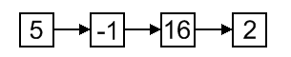

Each cell is called a node of a singly-linked list. First node is called head and it's a dedicated node. By knowing it, we can access every other node in the list. Sometimes, last node, called tail, is also stored in order to speed up add operation

Performance
1. The advantage of a singly linked list is its ability to expand to accept virtually unlimited number of nodes in a fragmented memory environment.
2. The disadvantage is its speed. Operations in a singly-linked list are slow as it uses sequential search to locate a node.

Doubly Linked List
Doubly-linked list is a more sophisticated form of linked list data structure. Each node of the list contain two references (or links) – one to the previous node and other to the next node. The previous link of the first node and the next link of the last node points to NULL. In comparison to singly-linked list, doubly-linked list requires handling of more pointers but less information is required as one can use the previous links to observe the preceding element. It has a dynamic size, which can be determined only at run time.
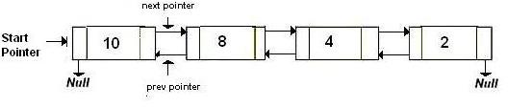

Performance
1. The advantage of a doubly linked list is that we don’t need to keep track of the previous node for traversal or no need of traversing the whole list for finding the previous node.
2. The disadvantage is that more pointers needs to be handled and more links need to updated.

Circular Linked List
Circular linked list is a more complicated linked data structure. In this the elements can be placed anywhere in the heap memory unlike array which uses contiguous locations. Nodes in a linked list are linked together using a next field, which stores the address of the next node in the next field of the previous node i.e. each node of the list refers to its successor and the last node points back to the first node unlike singly linked list. It has a dynamic size, which can be determined only at run time.

Performance
1. The advantage is that we no longer need both a head and tail variable to keep track of the list. Even if only a single variable is used, both the first and the last list elements can be found in constant time. Also, for implementing queues we will only need one pointer namely tail, to locate both head and tail.
Circular lists are useful in applications to repeatedly go around the list. For example, when multiple applications are running on a PC, it is common for the operating system to put the running applications on a list and then to cycle through them, giving each of them a slice of time to execute, and then making them wait while the CPU is given to another application. It is convenient for the operating system to use a circular list so that when it reaches the end of the list it can cycle around to the front of the list.
2. The disadvantage is that the algorithms have become more complicated.
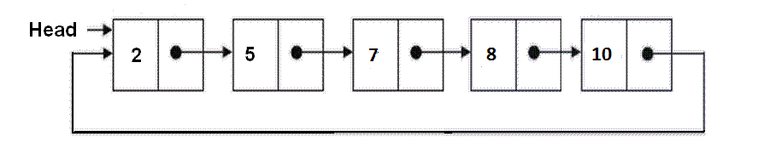

Basic Operations on a Circular Linked List
Insert – Inserts a new element at the end of the list.
Delete – Deletes any node from the list.
Find – Finds any node in the list.
Print – Prints the list

Insertion at the Beginning
Steps to insert a Node at beginning :
Step1. Create the new node
Step2. Set the new node’s next to itself (circular!)
Step3. If the list is empty,return new node.
Step4. Set our new node’s next to the front.
Step5. Set tail’s next to our new node.
Step6. Return the end of the list.
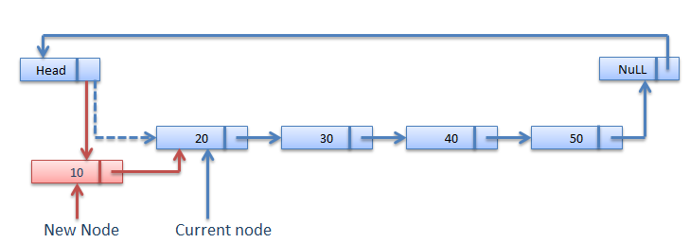

Insertion at the End
Steps to insert a Node at the end :
Step1. Create the new node
Step2. Set the new node’s next to itself (circular!)
Step3. If the list is empty,return new node.
Step4. Set our new node’s next to the front.
Step5. Set tail’s next to our new node.
Step6. Return the end of the list.
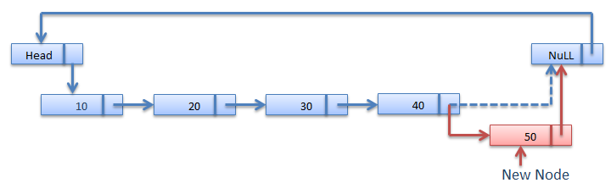

Searching for an Element in the List
In searching we do not have to do much, we just need to traverse like we did while getting the last node, in this case we will also compare the data of the Node. If we get the Node with the same data, we will return it, otherwise we will make our pointer point the next Node, and so on.

Deleting a Node from the List
Deleting a node can be done in many ways, like we first search the Node with data which we want to delete and then we delete it. In our approach, we will define a method which will take the data to be deleted as argument, will use the search method to locate it and will then remove the Node from the List.
To remove any Node from the list, we need to do the following :
- If the Node to be deleted is the first node, then simply set the Next pointer of the Head to point to the next element from the Node to be deleted. And update the next pointer of the Last Node as well.
- If the Node is in the middle somewhere, then find the Node before it, and make the Node before it point to the Node next to it.
- If the Node is at the end, then remove it and make the new last node point to the head.
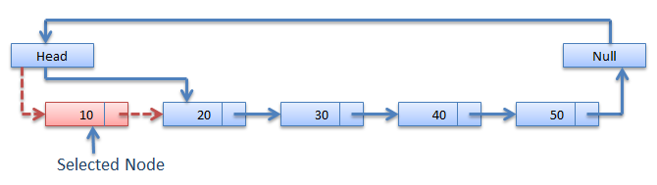

After Deletion

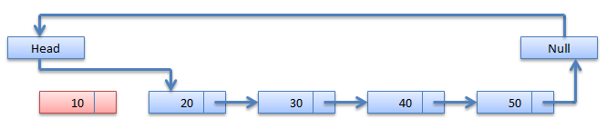

Applications of linked list
1) Multiple Precision Arithmetic
2)To implement associative arrays
3)Stack and Queue can be represnted dynamically using linked list
4)Representation and manipulation of polynomial expressions

Conclusion
Hence, we learnt insertion, deletion, sorting and merging linked list.

ASSIGNMENT NO. 10

PROBLEM STATEMENT:
Write a c++ program for storing binary number using doubly link list. Write functions
a) To compute 1’s and 2’s complement.
b) Add two binary numbers.

Theory

Doubly link list:
A doubly linked list is a linked data structure that consists of a set of sequentially linked records called nodes. Each node contains two fields, called links that are references to the previous and to the next node in the sequence of nodes. The beginning and ending nodes' previous and next links, respectively, point to some kind of terminator, typically a sentinel node or null, to facilitate traversal of the list. If there is only one sentinel node, then the list is circularly linked via the sentinel node. It can be conceptualized as two singly linked lists formed from the same data items, but in opposite sequential orders.

The two node links allow traversal of the list in either direction. While adding or removing a node in a doubly linked list requires changing more links than the same operations on a singly linked list, the operations are simpler and potentially more efficient (for nodes other than first nodes) because there is no need to keep track of the previous node during traversal or no need to traverse the list to find the previous node, so that its link can be modified.

The first and last nodes of a doubly linked list are immediately accessible (i.e., accessible without traversal, and usually called head and tail) and therefore allow traversal of the list from the beginning or end of the list, respectively: e.g., traversing the list from beginning to end, or from end to beginning, in a search of the list for a node with specific data value. Any node of a doubly linked list, once obtained, can be used to begin a new traversal of the list, in either direction (towards beginning or end), from the given node.
The link fields of a doubly linked list node are often called next and previous or forward and backward. The references stored in the link fields are usually implemented as pointers, but (as in any linked data structure) they may also be address offsets or indices into an array where the nodes live.

OPERATIONS OF DOUBLY LINK LIST:

Traversing the list
Traversal of a doubly linked list can be in either direction. In fact, the direction of traversal can change many times, if desired. Traversal is often called iteration, but that choice of terminology is unfortunate, for iteration has well-defined semantics (e.g., in mathematics) which are not analogous to traversal.

Inserting a node
These symmetric functions insert a node either after or before a given node

Removing a node
Removal of a node is easier than insertion, but requires special handling if the node to be removed is the first Node or last Node

Deleting a node
To remove a node, we simply modify the link pointed by prev, regardless of whether the node was the first one of the list.

Circular Linked List
Circular Linked List is little more complicated linked data structure. In the circular linked list we can insert elements anywhere in the list whereas in the array we cannot insert element anywhere in the list because it is in the contiguous memory. In the circular linked list the previous element stores the address of the next element and the last element stores the address of the starting element. The elements points to each other in a circular way which forms a circular chain. The circular linked list has a dynamic size which means the memory can be allocated when it is required.

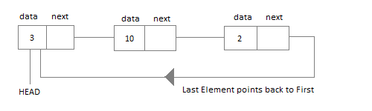

Doubly circular Linked List:
In doubly linked list, the next pointer of the last node points to the first node and the previous pointer of the first node points to the last node making the circular in both directions.

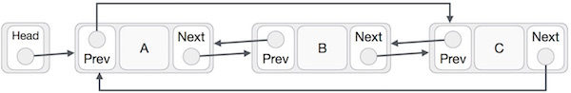

As per above shown illustrations, following are the important points to be considered.
- Last Link's next points to first link of the list in both cases of singly as well as doubly linked list.
- First Link's prev points to the last of the list in case of doubly linked list.

Application of linked lists is to polynomials. We now use linked lists to perform operations on polynomials. Let f(x) = Σdi=0 aixi. The quantity d is called as the degree of the polynomial, with the assumption that ad not equal to 0. A polynomial of degree d may however have missing terms i.e., powers j such that 0 <= j < d and aj = 0.The standard operations on a polynomial are addition and multiplication. If we store the coefficient of each term of the polynomials in an array of size d + 1, then these operations can be supported in a straight forward way. However, for sparse polynomials, i.e., polynomials where there are few non-zero coefficients, this is not efficient. One possible solution is to use linked lists to store degree, coefficient pairs for non-zero coefficients. With this representation, it makes it easier if we keep the list of such pairs in decreasing order of degrees.

A polynomial is a sum of terms. Each term consists of a coefficient and a (common) variable raised to an exponent. We consider only integer exponents, for now.
Example: 4x³ + 5x – 10.
How to represent a polynomial? Issues in representation, should not waste space, should be easy to use it for operating on polynomials .Any case, we need to store the coefficient and the exponent.

struct node
{
float coefficient;
int exponent;
struct node *next;
}

CONCLUSION:
Hence we successfully implemented doubly link list for storing binary number and its operations.

Assignment No. 11

Problem Statement:
Implement C++ program for expression conversion-
a) infix to prefix, b)prefix to postfix,

c) prefix to infix, d) postfix to infix and e) postfix to prefix.

Theory:

When you write an arithmetic expression such as B * C, the form of the expression provides you with information so that you can interpret it correctly. In this case we know that the variable B is being multiplied by the variable C since the multiplication operator * appears between them in the expression. This type of notation is referred to as infix since the operator is in between the two operands that it is working on.
Consider another infix example, A + B * C. The operators + and * still appear between the operands, but there is a problem. Which operands do they work on? Does the + work on A and B or does the * take B and C? The expression seems ambiguous.
In fact, you have been reading and writing these types of expressions for a long time and they do not cause you any problem. The reason for this is that you know something about the operators + and *. Each operator has a precedence level. Operators of higher precedence are used before operators of lower precedence. The only thing that can change that order is the presence of parentheses. The precedence order for arithmetic operators places multiplication and division above addition and subtraction. If two operators of equal precedence appear, then a left-to-right ordering or associativity is used.
Let’s interpret the troublesome expression A + B * C using operator precedence. B and C are multiplied first, and A is then added to that result. (A + B) * C would force the addition of A and B to be done first before the multiplication. In expression A + B + C, by precedence (via associativity), the leftmost + would be done first.
Although all this may be obvious to you, remember that computers need to know exactly what operators to perform and in what order. One way to write an expression that guarantees there will be no confusion with respect to the order of operations is to create what is called a fully parenthesized expression. This type of expression uses one pair of parentheses for each operator. The parentheses dictate the order of operations; there is no ambiguity. There is also no need to remember any precedence rules.
The expression A + B * C + D can be rewritten as ((A + (B * C)) + D) to show that the multiplication happens first, followed by the leftmost addition. A + B + C + D can be written as (((A + B) + C) + D) since the addition operations associate from left to right.
There are two other very important expression formats that may not seem obvious to you at first. Consider the infix expression A + B. What would happen if we moved the operator before the two operands? The resulting expression would be + A B. Likewise, we could move the operator to the end. We would get A B +. These look a bit strange.
These changes to the position of the operator with respect to the operands create two new expression formats, prefix and postfix. Prefix expression notation requires that all operators precede the two operands that they work on. Postfix, on the other hand, requires that its operators come after the corresponding operands. A few more examples should help to make this a bit clearer.
A + B * C would be written as + A * B C in prefix. The multiplication operator comes immediately before the operands B and C, denoting that * has precedence over +. The addition operator then appears before the A and the result of the multiplication.
In postfix, the expression would be A B C * +. Again, the order of operations is preserved since the * appears immediately after the B and the C, denoting that * has precedence, with + coming after. Although the operators moved and now appear either before or after their respective operands, the order of the operands stayed exactly the same relative to one another.
Table 2: Examples of Infix, Prefix, and Postfix
Infix Expression | Prefix Expression | Postfix Expression
A + B | + A B | A B +
A + B * C | + A * B C | A B C * +
Now consider the infix expression (A + B) * C. Recall that in this case, infix requires the parentheses to force the performance of the addition before the multiplication. However, when A + B was written in prefix, the addition operator was simply moved before the operands, + A B. The result of this operation becomes the first operand for the multiplication. The multiplication operator is moved in front of the entire expression, giving us * + A B C. Likewise, in postfix A B + forces the addition to happen first. The multiplication can be done to that result and the remaining operand C. The proper postfix expression is then A B + C *.
Consider these three expressions again (see Table 3). Something very important has happened. Where did the parentheses go? Why don’t we need them in prefix and postfix? The answer is that the operators are no longer ambiguous with respect to the operands that they work on. Only infix notation requires the additional symbols. The order of operations within prefix and postfix expressions is completely determined by the position of the operator and nothing else. In many ways, this makes infix the least desirable notation to use.
Table 3: An Expression with Parentheses
Infix Expression | Prefix Expression | Postfix Expression
(A + B) * C | * + A B C | A B + C *
Table 4 shows some additional examples of infix expressions and the equivalent prefix and postfix expressions. Be sure that you understand how they are equivalent in terms of the order of the operations being performed.
Table 4: Additional Examples of Infix, Prefix, and Postfix
Infix Expression | Prefix Expression | Postfix Expression
A + B * C + D | + + A * B C D | A B C * + D +
(A + B) * (C + D) | * + A B + C D | A B + C D + *
A * B + C * D | + * A B * C D | A B * C D * +
A + B + C + D | + + + A B C D | A B + C + D +

Infix Notation
We write expression in infix notation, e.g. a-b+c, where operators are used in-between operands. It is easy for us humans to read, write and speak in infix notation but the same does not go well with computing devices. An algorithm to process infix notation could be difficult and costly in terms of time and space consumption.

Prefix Notation
In this notation, operator is prefixed to operands, i.e. operator is written ahead of operands. For example +ab. This is equivalent to its infix notation a+b. Prefix notation is also known as Polish Notation.

Postfix Notation
This notation style is known as Reversed Polish Notation. In this notation style, operator is postfixed to the operands i.e., operator is written after the operands. For example ab+. This is equivalent to its infix notation a+b.
The below table briefly tries to show difference in all three notations −
S.n. | Infix Notation | Prefix Notation | Postfix Notation
1 | a + b | + a b | a b +
2 | (a + b) * c | * + a b c | a b + c *
3 | a * (b + c) | * a + b c | a b c + *
4 | a / b + c / d | + / a b / c d | a b / c d / +
5 | (a + b) * (c + d) | * + a b + c d | a b + c d + *
6 | ((a + b) * c) - d | - * + a b c d | a b + c * d -

Parsing Expressions
As we have discussed, it is not very efficient way to design an algorithm or program to parse infix notations. Instead, these infix notations are first converted into either postfix or prefix notations and then computed.
To parse any arithmetic expression, we need to take care of operator precedence and associativity also.

Precedence
When an operand is in between two different operator, which operator will take the operand first, is decided by the precedence of an operator over others. For example −
As multiplication operation has precedence over addition, b * c will be evaluated firs. A table of operator precedence is provided later.

Associativity
Associativity describes the rule where operators with same precedence appear in an expression. For example, in expression a+b−c, both + and − has same precedence, then which part of expression will be evaluated first, is determined by associativity of those operators. Here, both + and − are left associative, so the expression will be evaluated as (a+b−c).
Precedence and associativity, determines the order of evaluation of an expression. An operator precedence and associativity table is given below (highest to lowest) −
S.n. | Operator | Precedence | Associativity
1 | Esponentiation ^ | Highest | Right Associative
2 | Multiplication ( * ) & Division ( / ) | Second Highest | Left Associative
3 | Addition ( + ) & Subtraction ( − ) | Lowest | Left Associative
The above table shows the default behavior of operators. At any point of time in expression evaluation, the order can be altered by using parenthesis. For example −
In a+b*c, the expression part b*c will be evaluated first, as multiplication as precedence over addition. We here use parenthesis to make a+b be evaluated first, like (a+b)*c.

Postfix Evaluation Algorithm
We shall now look at the algorithm on how to evaluate postfix notation −
Step 1 − scan the expression from left to right
Step 2 − if it is an operand push it to stack
Step 3 − if it is an operator pull operand from stack and perform operation
Step 4 − store the output of step 3, back to stack
Step 5 − scan the expression until all operands are consumed
Step 6 − pop the stack and perform operation

Conclusion: We have implement C++ program for expression conversion.

Assignment No. 12

Problem Statement:
A classic problem that can be solved by backtracking is called the Eight Queens problem, which comes from the game of chess. The chess board consist of 64 square arranged in an 8 by 8 grid. The board normally alternates between black and white square, but this is not relevant for the present problem. The queen can move as far as she wants in any direction, as long as she follows a straight line, vertically, horizontally, or diagonally. Write C++ program with recursive function for generating all possible configurations for 4-queen's problem.
Theory:
The N Queen is the problem of placing N chess queens on an N×N chessboard so that no two queens attack each other. For example, following is a solution for 4 Queen problem.
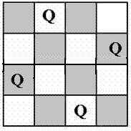
The expected output is a binary matrix which has 1s for the blocks where queens are placed. For example following is the output matrix for above 4 queen solution.
{ 0, 1, 0, 0}
{ 0, 0, 0, 1}
{ 1, 0, 0, 0}
{ 0, 0, 1, 0}

NaïveAlgorithm
Generate all possible configurations of queens on board and print a configuration that satisfies the given constraints.
while there are untried conflagrations
{
generate the next configuration
if queens don't attack in this configuration then
{
print this configuration;
}
}

BacktrackingAlgorithm
The idea is to place queens one by one in different columns, starting from the leftmost column. When we place a queen in a column, we check for clashes with already placed queens. In the current column, if we find a row for which there is no clash, we mark this row and column as part of the solution. If we do not find such a row due to clashes then we backtrack and return false.
1) Start in the leftmost column
2) If all queens are placed
return true
3) Try all rows in the current column. Do following for every tried row.
a) If the queen can be placed safely in this row then mark this [row, column] as part of the solution and recursively check if placing queen here leads to a solution.
b) If placing queen in [row, column] leads to a solution then
return true.
c) If placing queen doesn't lead to a solution then unmark this [row,column] (Backtrack) and go to step (a) to try other rows.
3) If all rows have been tried and nothing worked, return false to trigger
backtracking.
The n-queens problem is to find all ways to place n queens on an n x n checkerboard so that no queen may take another. As an example, the eight-queens problem is to find all ways to place eight queens on the chessboard so that no queen may take any other that is, move into a position on its next move that is occupied by any other queen. The question is how to solve the n-queens problem. At first glance this problem has little relation to trees, but let us see. It is not even clear that a solution exists for all n.
Since a queen can be moved along one of its rows, columns, or diagonals, a solution clearly is achieved by specifying how to place the n queens so that exactly one queen appears in each row and column, and no more than one queen appears on any diagonal of the board. One could attempt to find a solution by searching through all possible placements of the n queens satisfying these restrictions. There are, however, n! such placements. Even for a moderate n, this is obviously not a practical solution. Instead we must construct a solution. The idea behind the construction is to determine if the placements obtained for the first i queens can lead to a solution. If they cannot, abandon that construction and try another, since placing the remaining n - i queens will not be fruitful. This may avoid the need to consider all possible constructions.
To construct a solution involves testing a partial construction to determine whether or not it can lead to a solution or must be abandoned as a dead end. This testing is the next question.
Consider a general tree, with each of its nodes representing a sequence of decisions on the placement of queens. Take the root to represent the initial situation, in which no decisions have yet been made. The root will have n successors. Each successor corresponds to a choice of row for the placement of the first queen. Each of these successor nodes, in turn, has n successors, corresponding to a choice of row for the placement of the second queen, and so on. The tree for the four-queens problem is shown in Figure 7.17.
Since exactly one queen must appear in each column in any solution, assume the ith queen is placed in column i. Hence, each path, from the root to a node at depth i in the tree, specifies a partial construction in which the first i queens have been placed on the board. The path indicated in the four-queens tree specifies a partial construction in which the first, second, and third queens have been placed in rows 2, 4, and 1 (and columns 1, 2, and 3), respectively. The tree helps us visualize all possible solutions and provides a framework in which to view what we are doing.
Suppose a path has been found to a node at depth k. The path is feasible if none of the k queens whose positions are specified by the path can take any other. If the node at depth k is a terminal node, and the path is feasible, then a solution has been found and may be printed. If the node at depth k is not terminal, and the path is feasible, we want to extend the path to a node at depth k + 1. Let p point to such a node. Then node.p must be a successor of the node on the path at depth k.
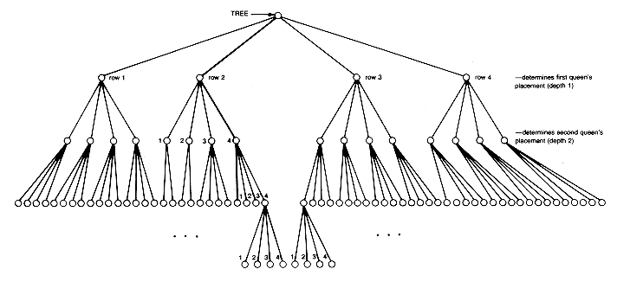

Figure 7.17 Tree for the Four-queens Problem
P is feasible if the position that node. p specifies for the (k + 1)th queen does not allow it to take any of the other k queens. If p is feasible, the path can be extended downward in the tree to include node.p, so there is now a feasible path of depth k + 1. If p is not feasible, then another successor of the node at depth k must be tried until a feasible one is found to extend the path, or until all have been tried and none is feasible. In the latter case, the choice of node at depth k cannot be extended to a solution, and the computer backs up in the tree to a node representing a shorter path that has not yet been explored. This procedure to extend the new path is repeated until a solution is found or until all possibilities have been tried.
The procedure described amounts to a modified general tree traversal called backtracking. A different approach would be to create an algorithm for the problem by applying a general tree preorder traversal that uses a process routine. The process routine would check each node to be processed to see whether the node is terminal and represents a feasible path. If so, it prints the solution. This approach amounts to an exhaustive search of all n! possibilities, since the preorder traversal backs up only when the preorder traversal of a subtree has been completed that is, after a terminal node has been processed. The backtracking traversal need not access and process all nodes. It backs up when the traversal of a subtree has been completed or when it becomes known that no path involving the root of a subtree can be extended to a solution. The backtracking procedure generates only feasible paths not all paths. In effect, it prunes the tree by ignoring all nodes that cannot lead to a solution.

Assignment No. 13

Problem Statement:
Write program to implement a priority queue in C++ using an inorder List to store the items in the queue. Create a class that includes the data items(which should be template) and the priority (which should be int)The inorder list should contain these objects ,with operator <= overloaded so that the items with highest priority appear at the beginning of the list (which will make it relatively easy to retrieve the highest item.)

Theory
Priority Queue
Priority queue is an abstract data type which is like a regular queue or stack data structure, but where additionally each element has a "priority" associated with it. In a priority queue, an element with high priority is served before an element with low priority. If two elements have the same priority, they are served according to their order in the queue.
Priority Queue is more specialized data structure than Queue. Like ordinary queue, priority queue has same method but with a major difference. In Priority queue items are ordered by key value so that item with the lowest value of key is at front and item with the highest value of key is at rear or vice versa. So we're assigned priority to item based on its key value. Lower the value, higher the priority. Following are the principal methods of a Priority Queue.
An important application of a priority queue is sorting
• PriorityQueueSort (collection S of n elements)
• put the elements in S in an initially empty priority queue by means of a series of n insert() operations on the pqueue, one for each element
• extract the elements from the pqueue by means of a series of n removeMin() operations

Basic Operations
- insert / enqueue − add an item to the rear of the queue.
- remove / dequeue − remove an item from the front of the queue.

Priority Queue Representation
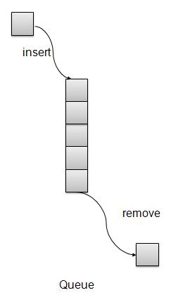

There are few more operations supported by queue which are following.
- getHighestPriority(): Returns the highest priority item.
- Peek − get the element at front of the queue.
- isFull − check if queue is full.
- isEmpty − check if queue is empty.
Using Array: We're going to implement Queue using array. A simple implementation is to use array of following structure.
Struct item{
Int item;
Int priority;
}
insert() operation can be implemented by adding an item at end of array in O(1) time.
getHighestPriority() operation can be implemented by linearly searching the highest priority item in array. This operation takes O(n) time.
deleteHighestPriority() operation can be implemented by first linearly searching an item, then removing the item by moving all subsequent items one position back.
We can also use Linked List, time complexity of all operations with linked list remains same as array. The advantage with linked list is deleteHighestPriority() can be more efficient as we don’t have to move items.

Insert / Enqueue Operation
Whenever an element is inserted into queue, priority queue inserts the item according to its order. Here we're assuming that data with high value has low priority.
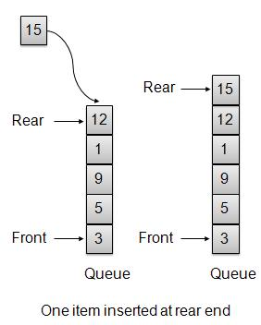

Remove / Dequeue Operation
Whenever an element is to be removed from queue, queue get the element using item count. Once element is removed. Item count is reduced by one.
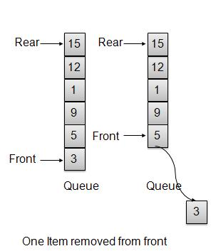
Conclusion
Hence, we learnt to implement a priority queue in C++ using an inorder.

Assignment No. 14

Problem Statement:
Pizza parlor accepting maximum M orders. Orders are served in first come first served basis. Order once placed cannot be cancelled. Write C++ program to simulate the system using circular queue using array.
Theory
CIRCULAR QUEUE:
A circular queue is an abstract data type that contains a collection of data which allows addition of data at the end of the queue and removal of data at the beginning of the queue. Circular queues have a fixed size. In a standard queue data structure re-buffering problem occurs for each dequeue operation. To solve this problem by joining the front and rear ends of a queue to make the queue as a circular queue Circular queue is a linear data structure. It follows FIFO principle.
- In circular queue the last node is connected back to the first node to make a circle.
- Circular linked list fallow the First In First Out principle
- Elements are added at the rear end and the elements are deleted at front end of the queue
- Both the front and the rear pointers points to the beginning of the array.
- It is also called as “Ring buffer”.
- Items can inserted and deleted from a queue in O(1) time.
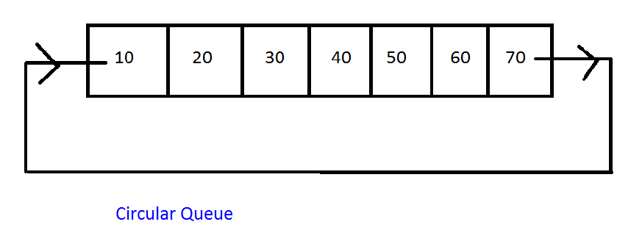
Circular Queue can be created in three ways they are
· Using single linked list
· Using double linked list
· Using arrays
Using array
In arrays the range of a subscript is 0 to n-1 where n is the maximum size. To make the array as a circular array by making the subscript 0 as the next address of the subscript n-1 by using the formula subscript = (subscript +1) % maximum size. In circular queue the front and rear pointer are updated by using the above formula.
To implement a circular queue data structure using array, we first perform the following steps before we implement the actual operation:
Step 1: include all the header files which are used in program and define the constant SIZE with specific value.
Step 2: Declare all user defined functions used in circular queue implementation.
Step 3: Create a one dimension array with above defined SIZE.
Step 4: Define two integer variables ‘front’ and ‘rear’ and initialize both with ‘-1’ (int front=-1, rear=-1).
Step 5: Implement main method by displaying menu of operation list and make suitable fuction calls to perform operation selected by the user on the circular queue.

Algorithm for Enqueue operation using array
Step 1. start
Step 2. if (front == (rear+1)%max)
Print error “circular queue overflow “
Step 3. else
{ rear = (rear+1)%max
Q[rear] = element;
If (front == -1 ) f = 0;
}
Step 4. stop

Algorithm for Dequeue operation using array
Step 1. start
Step 2. if ((front == rear) && (rear == -1))
Print error “circular queue underflow “
Step 3. else
{ element = Q[front]
If (front == rear) front=rear = -1
Else
Front = (front + 1) % max
}
Step 4. Stop

Algorithm for create ( ) function:-
Step 1) allocate the memory for newnode
newnode = new (node )
Step 2) newnode->next=newnode. // circular
Step 3) Repeat the steps from 4 to 5 until choice = ‘n’
Step 4) if (root=NULL)
root = prev=newnode // prev is a running pointer which points last node of a list
else
newnode->next = root
prev->next = newnode
prev = newnode
Step 5) Read the choice
Step 6) return
Algorithm for display ( ) function :-
Step 1) start
Step 2) declare a variable of pointer to structure node called temp, assign root to temp
temp = root
Step 3) display temp->info
Step 4) temp = temp->next
Step 5) repeat the steps 6 until temp = root
Step 6) display temp info
Step 7) temp=temp->next
Step 8) return

Conclusion
Hence, we learnt to implement circular queue using array in C++.

Assignment No. 15

Problem Statement:
a) Write C++ program to store roll numbers of student in array who attended training program in random order. Write function for searching whether particular student attended training program or not using linear search and sentinel search.
b) Write C++ program to store roll numbers of student array who attended training program in sorted order. Write function for searching whether particular student attended training program or not using binary search and Fibonacci search.

Theory

Linear Search
A linear search is the basic and simple search algorithm. A linear search searches an element or value from an array till the desired element or value is not found and it searches in a sequence order. It compares the element with all the other elements given in the list and if the element is matched it returns the value index else it return -1. Linear Search is applied on the unsorted or unordered list when there are fewer elements in a list.

Example with Implementation
To search the element 5 it will go step by step in a sequence order.
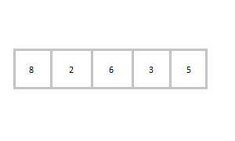
function findIndex(values, target)
{
for(var i = 0; i < values.length; ++i)
{
if (values[i] == target)
{
return i;
}
}
return -1;
}
//call the function findIndex with array and number to be searched
findIndex([ 8 , 2 , 6 , 3 , 5 ] , 5) ;

Binary Search
Binary Search is applied on the sorted array or list. In binary search, we first compare the value with the elements in the middle position of the array. If the value is matched, then we return the value. If the value is less than the middle element, then it must lie in the lower half of the array and if it's greater than the element then it must lie in the upper half of the array. We repeat this procedure on the lower (or upper) half of the array. Binary Search is useful when there are large numbers of elements in an array.

Example with Implementation
To search an element 13 from the sorted array or list.
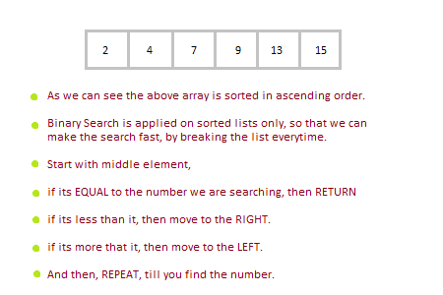
function findIndex(values, target)
{
return binarySearch(values, target, 0, values.length - 1);
};

function binarySearch(values, target, start, end) {
if (start > end) { return -1; } //does not exist

var middle = Math.floor((start + end) / 2);
var value = values[middle];

if (value > target) { return binarySearch(values, target, start, middle-1); }
if (value < target) { return binarySearch(values, target, middle+1, end); }
return middle; //found!
}
findIndex([2, 4, 7, 9, 13, 15], 13);
In the above program logic, we are first comparing the middle number of the list, with the target, if it matches we return. If it doesn't, we see whether the middle number is greater than or smaller than the target.
If the Middle number is greater than the Target, we start the binary search again, but this time on the left half of the list, that is from the start of the list to the middle, not beyond that.
If the Middle number is smaller than the Target, we start the binary search again, but on the right half of the list, that is from the middle of the list to the end of the list.

Assignment No. 16

Problem Statement:
a) Write C++ program to store names and mobile numbers of your friends in sorted order on names. Search your friend from list using binary search (recursive and non recursive). Insert friend if not present in phonebook.
b) Write C++ program to store names and mobile numbers of your friends in sorted order on names. Search your friend from list using Fibonacci search. Insert friend if not present in phonebook.

THEORY
The Fibonacci search technique is a method of searching a sorted array using a divide and conquer algorithm that narrows down possible locations with the aid of Fibonacci numbers. Compared to binary search where the sorted array is divided into two arrays which are both examined recursively and recombined, Fibonacci search only examines locations whose addresses have lower dispersion. Therefore, when the elements being searched have non-uniform access memory storage (i.e., the time needed to access a storage location varies depending on the location previously accessed), the Fibonacci search has an advantage over binary search in slightly reducing the average time needed to access a storage location. Note, however, that large arrays not fitting in CPU cache or even in RAM can also be considered as non-uniform access examples. Fibonacci search has a complexity of O(log(n)) (see Big O notation).

Algorithm:
Let the searched element be x.
The idea it to first find the smallest Fibonacci number that is greater than or equal to length of given array. Let the found fibonacci number be fib (m’th fibonacci number). We use (m-2)’th Fibonacci number as index (If it is a valid index). Let (m-2)’th Fibonacci Number be i, we compare arr[i] with x, if x is same, we return i. Else if x is greater, we recur for subarray after i, else we recur for subarray before i.
Below is complete algorithm
Let arr[0..n-1] be th input array and element to be searched be x.
- Find the smallest Fibonacci Number greater than or equal n. Let this number be fibM [m’th Fibonacci Number]. Let the two Fibonacci numbers preceding it be fibMm1 [(m-1)’th Fibonacci Number and fibMm2 [(m-2)’th Fibonacci Number./li>
- While the array has elements to be inspected:
  - Compare x with the last element of the range covered by fibMm2
  - If x matches, return index
  - Else If x is less than the element, move the three Fibonacci variables two Fibonacci down, indicating elimination of approximately rear two-third of the remaining array.
  - Else x is greater than the element, move the three Fibonacci variables one Fibonacci down. Reset offset to index. Together these indicate elimination of approximately front one-third of the remaining array.
- Since there might be a single element remaining for comparison, check if fibMm1 is 1. If Yes, compare x with that remaining element. If match, return index.

INTERNAL SORTING-:
An internal sort is any data sorting process that takes place entirely within the main memory of a computer. This is possible whenever the data to be sorted is small enough to all be held in the main memory. For sorting larger datasets, it may be necessary to hold only a chunk of data in memory at a time, since it won’t all fit. The rest of the data is normally held on some larger, but slower medium, like a hard-disk. Any reading or writing of data to and from this slower media can slow the sorting process considerably. This issue has implications for different sort algorithms.
Some common internal sorting algorithms include:
- Bubble Sort
- Insertion Sort
- Quick Sort
- Heap Sort
- Radix Sort
- Selection sort

EXTERNAL SORTING-:
External sorting is a term for a class of sorting algorithms that can handle massive amounts of data. External sorting is required when the data being sorted do not fit into the main memory of a computing device (usually RAM) and instead they must reside in the slower external memory (usually a hard drive). External sorting typically uses a hybrid sort-merge strategy. In the sorting phase, chunks of data small enough to fit in main memory are read, sorted, and written out to a temporary file. In the merge phase, the sorted sub files are combined into a single larger file.

Sorting Efficiency
There are many techniques for sorting. Implementation of particular sorting technique depends upon situation. Sorting techniques mainly depends on two parameters. First parameter is the execution time of program, which means time taken for execution of program. Second is the space, which means space taken by the program.

EFFICIENCY AND PASSES-:
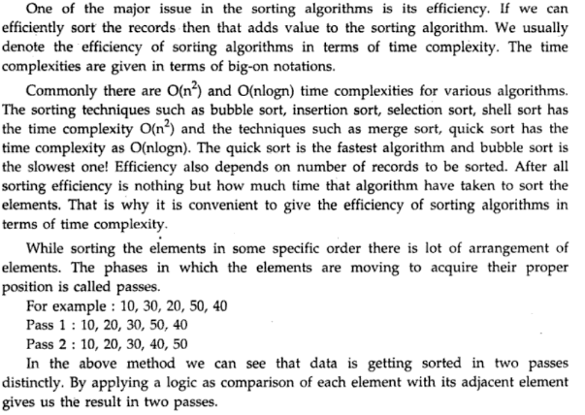
CONCLUSION-:
.

.

Assignment No. 17-A

Problem Statement:
Write C++ program to store first year percentage of students in array. Write function for sorting array of floating point numbers in ascending order using
a) Selection Sort
b) Bubble sort and display top five scores.

Theory:

Selection Sort
Selection sort is a simple sorting algorithm. This sorting algorithm is a in-place comparison based algorithm in which the list is divided into two parts, sorted part at left end and unsorted part at right end. Initially sorted part is empty and unsorted part is entire list.
Smallest element is selected from the unsorted array and swapped with the leftmost element and that element becomes part of sorted array. This process continues moving unsorted array boundary by one element to the right.
This algorithm is not suitable for large data sets as its average and worst case complexity are of O(n²) where n are no. of items.

Working of selection Sort:
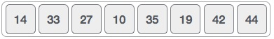
For the first position in the sorted list, the whole list is scanned sequentially. The first position where 14 is stored presently, we search the whole list and find that 10 is the lowest value.

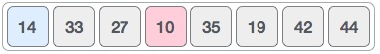
So we replace 14 with 10. After one iteration 10, which happens to be the minimum value in the list, appears in the first position of sorted list.

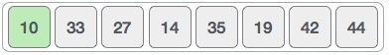

For the second position, where 33 is residing, we start scanning the rest of the list in linear manner.

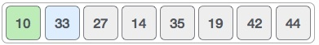

We find that 14 is the second lowest value in the list and it should appear at the second place. We swap these values.

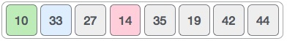
After two iterations, two least values are positioned at the the beginning in the sorted manner.

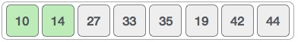

The same process is applied on the rest of the items in the array. We shall see an pictorial depiction of entire sorting process −
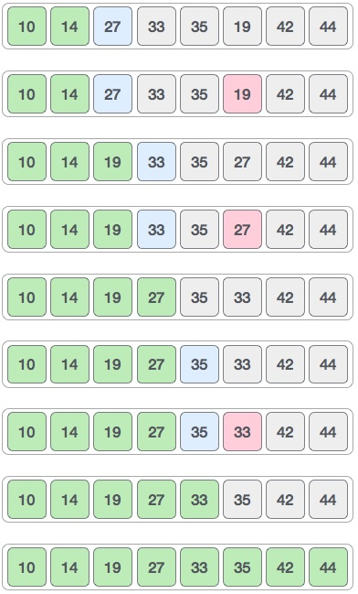

Bubble Sort:
Bubble sort, sometimes incorrectly referred to as sinking sort, is a simple sorting algorithm that works by repeatedly stepping through the list to be sorted, comparing each pair of adjacent items and swapping them if they are in the wrong order. The pass through the list is repeated until no swaps are needed, which indicates that the list is sorted. The algorithm gets its name from the way smaller elements "bubble" to the top of the list. Because it only uses comparisons to operate on elements, it is a comparison sort. Although the algorithm is simple, most of the other sorting algorithms are more efficient for large lists.

Working of Bubble Sort:
We take an unsorted array for our example. Bubble sort take Ο(n²) time so we're keeping short and precise.
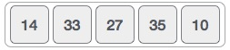
Bubble sort starts with very first two elements, comparing them to check which one is greater.
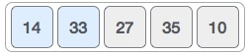
In this case, value 33 is greater than 14, so it is already in sorted locations. Next, we compare 33 with 27.
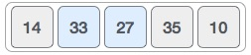
We find that 27 is smaller than 33 and these two values must be swapped.
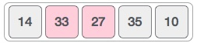
The new array should look like this −
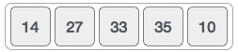
Next we compare 33 and 35. We find that both are in already sorted positions.
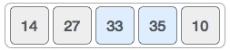
Then we move to next two values, 35 and 10.
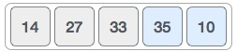
We know than 10 is smaller 35. Hence they are not sorted.
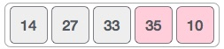
We swap these values. We find that we reach at the end of the array. After one iteration the array should look like this −
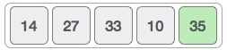
To be precise, we are now showing that how array should look like after each iteration. After second iteration, it should look like this −
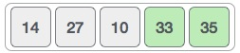
Notice that after each iteration, at least one value moves at the end.
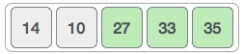
And when there's no swap required, bubble sorts learns that array is completely sorted.
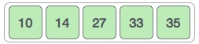
Conclusion
Hence, we learned to use selection sort and bubble sort.

Assignment No. 17-B

Problem Statement:
Write C++ program to store second year percentage of students in array. Write function for sorting array of floating point numbers in ascending order using
a) Insertion sort
b) Shell Sort and display top five scores.

Theory
Insertion Sort
This is a in-place comparison based sorting algorithm. Here, a sub-list is maintained which is always sorted. For example, the lower part of an array is maintained to be sorted. A element which is to be inserted in this sorted sub-list, has to find its appropriate place and insert it there. Hence the name insertion sort.
The array is searched sequentially and unsorted items are moved and inserted into sorted sub-list (in the same array). This algorithm is not suitable for large data sets as its average and worst case complexity are of Ο(n²) where n are no. of items.

Example:
Insertion sort compares the first two elements.
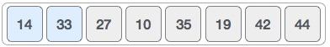
It finds that both 14 and 33 are already in ascending order. For now, 14 is in sorted sub-list.
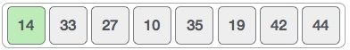
Insertion sort moves ahead and compares 33 with 27.
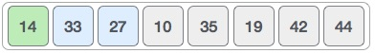
And finds that 33 is not in correct position.
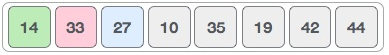
It swaps 33 with 27. Also it checks with all the elements of sorted sublist. Here we see that sorted sub-list has only one element 14 and 27 is greater than 14. Hence sorted sub-list remain sorted after swapping.
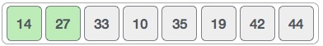
By now we have 14 and 27 in the sorted sublist. Next it compares 33 with 10,.
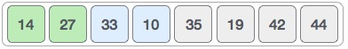
These values are not in sorted order.
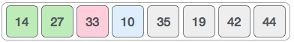
So we swap them.
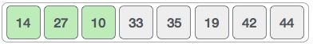
But swapping makes 27 and 10 unsorted.
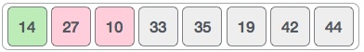
So we swap them too.
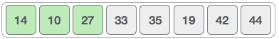
Again we find 14 and 10 in unsorted order.
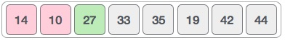
And we swap them. By the end of third iteration we have a sorted sublist of 4 items.
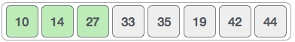
This process goes until all the unsorted values are covered in sorted sublist.

Shell Sort
Theory: Shell sort, also known as Shell sort or Shell's method, is an in-place comparison sort. It can either be seen as a generalization of sorting by exchange (bubble sort) or sorting by insertion (insertion sort).^{[1]} The method starts by sorting elements far apart from each other and progressively reducing the gap between them. Starting with far apart elements can move some out-of-place elements into position faster than a simple nearest neighbor exchange. Donald Shell published the first version of this sort in 1959.^{[2][3]} The running time of Shellsort is heavily dependent on the gap sequence it uses. For many practical variants, determining their time complexity remains an open problem.

Description: Shell sort is a generalization of insertion sort that allows the exchange of items that are far apart. The idea is to arrange the list of elements so that, starting anywhere, considering every hth element gives a sorted list. Such a list is said to be h-sorted. Equivalently, it can be thought of as h interleaved lists, each individually sorted.^{[4]} Beginning with large values of h, this rearrangement allows elements to move long distances in the original list, reducing large amounts of disorder quickly, and leaving less work for smaller h-sort steps to do. If the file is then-sorted for some smaller integer k, then the file remains h-sorted. Following this idea for a decreasing sequence of h values ending in 1 is guaranteed to leave a sorted list in the end.

An example run of Shell sort with gaps 5, 3 and 1 is shown below.
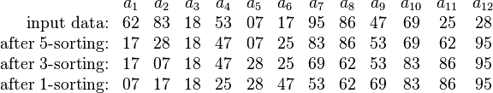
The first pass, 5-sorting, performs insertion sort on separate subarrays (a₁, a₆, a₁₁), (a₂, a₇, a₁₂), (a₃, a₈), (a₄, a₉), (a₅, a₁₀). For instance, it changes the subarray (a₁, a₆, a₁₁) from (62, 17, 25) to (17, 25, 62). The next pass, 3-sorting, performs insertion sort on the subarrays (a₁, a₄, a₇, a₁₀), (a₂, a₅, a₈, a₁₁), (a₃, a₆, a₉, a₁₂). The last pass, 1-sorting, is an ordinary insertion sort of the entire array (a₁,..., a₁₂). As the example illustrates, the subarrays that Shell sort operates on are initially short; later they are longer but almost ordered. In both cases insertion sort works efficiently. Shell sort is unstable: it may change the relative order of elements with equal values. It has "natural" behavior, in that it executes faster when the input is partially sorted.

Conclusion
Hence, we have learned the working of insertion sort and shell sort.

Assignment No. 17-C

Problem Statement:
Write C++ program to store first year percentage of students in array. Write function for sorting array of floating point numbers in ascending order using quick sort and display top five scores.

Quick Sort:

The quick sort is an in-place, divide-and-conquer, massively recursive sort. As a normal person would say, it's essentially a faster in-place version of the merge sort. The quick sort algorithm is simple in theory, but very difficult to put into code.

The recursive algorithm consists of four steps:
1. If there is one or less elements in the array to be sorted, return immediately.
2. Pick an element in the array to serve as a "pivot" point. (Usually the left-most element in the array is used.)
3. Split the array into two parts - one with elements larger than the pivot and the other with elements smaller than the pivot.
4. Recursively repeat the algorithm for both halves of the original array.

The quick sort is by far the fastest of the common sorting algorithms.

Algorithm:

1. Get N elements which are to be sorted, and store it in the array A.
2. Select the element from A[0] to A[N-1] for middle. This element is the pivot.
3. Partition the remaining elements into the segments left and right so that no elements in left has key larger than that of the pivot and no elements in right has a key smaller than that of the pivot.
4. Sort left using quick sort recursively.
5. Sort right using quick sort recursively.
6. Display the sorted array A.

Example:
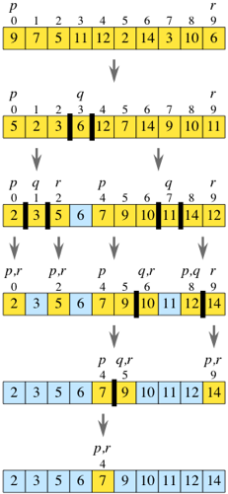

Assignment No. 17-D

Problem Statement:
Write C++ program to store XIIth percentage of students in array. Write function for sorting array of floating point numbers in ascending order using bucket sort and display top five scores.

Theory:
Bucket Sort
Bucket sort can be exceptionally fast because of the way elements are assigned to buckets, typically using an array where the index is the value. This means that more auxiliary memory is required for the buckets at the cost of running time than more comparison sorts. It runs in O(n+k) time in the average case where n is the number of elements to be sorted and k is the number of buckets.
While bucket sort is a distribution sort, it typically uses a comparison sort to sort the buckets after they have been allocated.

Working:
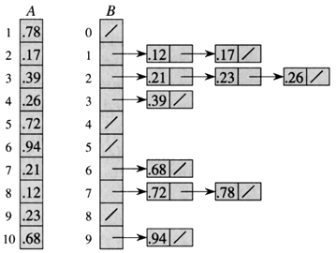
Time Complexity:
If we assume that insertion in a bucket takes O(1) time then steps 1 and 2 of the above algorithm clearly take O(n) time. The O(1) is easily possible if we use a linked list to represent a bucket (In the following code, C++ vector is used for simplicity). Step 4 also takes O(n) time as there will be n items in all buckets.
The main step to analyze is step 3. This step also takes O(n) time on average if all numbers are uniformly distributed

Assignment No. 17-E

Problem Statement:
Write C++ program to store Xth percentage of students in array. Write function for sorting array of floating point numbers in ascending order using radix sort and display top five scores.

Theory:
Radix Sort is a clever and intuitive little sorting algorithm. Radix Sort puts the elements in order by comparing the digits of the numbers. I will explain with an example.
Consider the following 9 numbers:
493 812 715 710 195 437 582 340 385
We should start sorting by comparing and ordering the one's digits:
Digit | Sublist
0 | 340 710
1
2 | 812 582
3 | 493
4
5 | 715 195 385
6
7 | 437
8
9
Notice that the numbers were added onto the list in the order that they were found, which is why the numbers appear to be unsorted in each of the sublists above. Now, we gather the sublists (in order from the 0 sublist to the 9 sublist) into the main list again:
340 710 812 582 493 715 195 385 437
Note: The order in which we divide and reassemble the list is extremely important, as this is one of the foundations of this algorithm.
Now, the sublists are created again, this time based on the ten's digit:
Digit | Sublist
0
1 | 710 812 715
2
3 | 437
4 | 340
5
6
7
8 | 582 385
9 | 493 195
Now the sublists are gathered in order from 0 to 9:
710 812 715 437 340 582 385 493 195
Finally, the sublists are created according to the hundred's digit:
Digit | Sublist
0
1 | 195
2
3 | 340 385
4 | 437 493
5 | 582
6
7 | 710 715
8 | 812
9
At last, the list is gathered up again:
195 340 385 437 493 582 710 715 812
And now we have a fully sorted array! Radix Sort is very simple, and a computer can do it fast. When it is programmed properly, Radix Sort is in fact one of the fastest sorting algorithms for numbers or strings of letters.
Disadvantages:
Still, there are some tradeoffs for Radix Sort that can make it less preferable than other sorts. The speed of Radix Sort largely depends on the inner basic operations, and if the operations are not efficient enough, Radix Sort can be slower than some other algorithms such as Quick Sort and Merge Sort. These operations include the insert and delete functions of the sublists and the process of isolating the digit you want. In the example above, the numbers were all of equal length, but many times, this is not the case. If the numbers are not of the same length, then a test is needed to check for additional digits that need sorting. This can be one of the slowest parts of Radix Sort, and it is one of the hardest to make efficient.
Radix Sort can also take up more space than other sorting algorithms, since in addition to the array that will be sorted, you need to have a sublist for each of the possible digits or letters. If you are sorting pure English words, you will need at least 26 different sublists, and if you are sorting alphanumeric words or sentences, you will probably need more than 40 sublists in all!
Since Radix Sort depends on the digits or letters, Radix Sort is also much less flexible than other sorts. For every different type of data, Radix Sort needs to be rewritten, and if the sorting order changes, the sort needs to be rewritten again. In short, Radix Sort takes more time to write, and it is very difficult to write a general purpose Radix Sort that can handle all kinds of data. For many programs that need a fast sort, Radix Sort is a good choice. Still, there are faster sorts, which is one reason why Radix Sort is not used as much as some other sorts.
Oral Questions

GROUP A
ASSIGNMENT 1
- What is disjoint set?
- What are the different operations on sets?
- What are the different properties of sets?
- What is proper subset?
- What is singleton set or unit set?
- What is algebra of set of laws?
- What do you mean by multiset?
- Explain the principle of exclusion and inclusion?
- What is Cartesian product?
10.Define De-Morgan’s Law.

ASSIGNMENT 2
1) When is the worst case occured in linear search algorithm?
2) What does the complexity of sorting algorithm measures as a function of the number n of items to be sorter?
3) When does Average case occurs in linear search algorithm?
4) The complexity of bubble sort algorithm is .....
5) ............order is the best possible for array sorting algorithm which sorts n item
6) Which order is the best possible for array sorting algorithm which sorts n item?
7) The time complexity of a quick sort algorithm which makes use of median, found by an O(n) algorithm, as pivot element is?
8) Which are the notations of time complexity?
9) Time complexity of bubble sort in best case is?
10. Counting sort performs …………. Numbers of comparisons between input elements.

ASSIGNMENT 3
Q1. What do you mean by permutation and combination?
Q2. Give the formula for permutation and combination?
Q3. State the difference between permutation and combination?
Q4. What are the different fundamental principles of counting?
Q5. What are the types of permutations?
Q6. Explain the password code?
Q7. Give some examples on permutations and combinations?
Q8. What are the applications of permutations and combinations?
Q9. Describe some basic operations of permutation?
Q10. What is the use of keyword ‘rand’ in the password program?

ASSIGNMENT 4
Q.1 Define row matrix?
Q.2 If all the element of two equal square matrices i.e. all a[i][j]=b[i][j] are equal ,can we say matrices equal or not?
Q.3 if all the elements of two equal size square matrices i.e. all a[i][j]=b[j][i]are equal , will b matrix be transpose of matrix ‘a’?
Q.4 Transpose can be only done if matrix is square matrix , is it true or false?
Q.5 What is square matrix?
Q.6 Representation of size of a matrix is…….*……….?
Q.7 How addition is performed in matrix?
Q.8 What will (A^{T})^{T}=……?
Q.9 What is a diagonal matrix?
Q.10 Define identity matrix?
ASSIGNMENT 5
1. How does transpose of a squre matrix found?
2.What is symmetricty?
3.In order to multiplication of 2 matrix no. of columns of a matrix is equal to_______________________________________?
4.What is an array?
5.How many types of array?
6.Define 1D array?
7.Definemulti dimensional array?
8.2D array are generally used in?
9.Twomatricies to be added must be___________________?
10.Explain the mapping of a 2D array?

ASSIGNMENT 6
Q.1 What does the string(string1,string2) library function mean ?
Q.2 Give any 2 operations that can be performed using string.
Q.3 What is the library function to concatenate two strings, string2 is appended to string 1 ?
Q.4 Under which header file string handling functions are defined ?
Q.5 Which two functions are handled in string ?
Q.6 What is the output of the following program ?
#include<stdio.h>
int main()
{
char string[20] = “ABCD”;
printf(“The string is : %s \n”,string);
return 0;
}
Q.7 Which library function gives length of string ?
Q.8 What is the loop used for scanning string in an array?
Q.9 Explain the code ?
Q.10 What is the logic for palindrome?

ASSIGNMENT 7
Q1. How to find the first repeating element in an array of integer?
Q2. Why do we need algorithm analysis?
Q3. What is linear data structure?
Q4. What are asymptotic notations?
Q5. What is the worst case run time complexity of binary search?
Q6. Is dynamic allocation of array possible in c?
Q7. Which is the algorithm design technique used in the quick sort algorithm?
Q8. Define time complexity?
Q9. What are the two main measures for the efficiency of algorithm?
Q10.How to display multidimensional array ?

GROUP B

Q 1] What are the merits of linked list over array?
Q2] What are the memory management functions during runtime?
Q3] Explain in brief what is the structure of a singly linked list and also explain what
Does each of its part consist of?
Q4] Give the importance of a head pointer?
Q5] State any 5 basic operations performed on singly linked list?
Q 6]What is the basic concept of Linked list?
Q 7]What is the main difference between Array and Linked list?
Q 8]Describe the different types of Linked lists in short?
Q 9]What is the main advantage of Linked list?
Q 10]Which basic operations can be performed on the Linked list?
Q 10]Why is insertion or deletion in a Linked List a constant time operation?
Q 11]What is the difference between algorithms of Insertion and Deletion of any nodes?
Q12]explain the situation of underflow in link list ?
Q13]how many null pointer are there in a doubly circular link list ?
Q14]what is the time required to delete a node with given address between singly and doubly link list?
Q15]what is the difference between singly and doubly link list?
Q16]explain the term of insertion in doubly link list?
Q17]explain the three term of deletion in link list?
Q18]what are the application of circular link list?
Q19]what are the operation perform on doubly link list?
Q20]explain the term of garbage collection?
Q21]A linear collection of data elements where the linear node is given by means of pointer is called?
Q22]Which of the following operations is performed more efficiently by doubly linked list than by singly linked list?
Q23]What would be the asymptotic time complexity to add an element in the linked list?
Q24]Consider the following definition in c programming language
struct node
{
int data;
struct node * next;
}
typedefstruct node NODE;
NODE *ptr;
- Which of the following c code is used to create new node?
ANS: ptr=(NODE*)malloc(sizeof(NODE));
Linked lists are not suitable to for the implementation of?
In worst case, the number of comparison need to search a singly linked list of length n for a given element is?
The concatenation of two list can performed in O(1) time. Which of the following variation of linked list can be used?
Q26] What are the applications of circular link list..? Explain any one application..?
Q27 What is the logic behind the insertion and deletion of a node into a circular link list..?
Q28] Explain the code for insertion of a node at a specified position into a circular link list..?
Q29] Explain the code for traversing a circular linked list..?
Q30] What is the use of 'flags' in circular link list..?
Q31]Consider an implementation of unsorted singly linked list. Suppose it has its representation with a head and tail pointer. Given the representation, which of the following operation can be implemented in O(1) time?
ANS=Deletion of the front node of linked list.
Q32]Each node in singly linked list has fields.?
ANS = 2

Q33]Each node in a linked list must contain at least ?
ANS=Two fields

Q34]To insert a new node in linked list free node will be available in ?
ANS Avail list

Q35]Header linked lists are frequently used for maintaining in memory?
ANS= Polynomials

Q36]Linked lists are not suitable to for the implementation of?
Q37] In circular linked list, insertion of node requires modification of?
Q38] A variant of the linked list in which none of the node contains NULL pointer is?
Q39] What kind of linked list is best to answer question like “What is the item at position n?
Ans) Array implementation of linked list.
Q40] The concatenation of two list can performed in O(1) time. Which of the following variation of linked list can be used?
Q41]Which of the following operations is performed more efficiently by doubly linked list than by singly linked list?
Q42] A linear collection of data elements where the linear node is given by means of pointer is called?
Q43]How is circular link list different from singly link list
Q44]Stack and Queue are dynamically represented using
Q45]Which is the more sophisticated linked list among all &why?
Q46]What kind of operations are performed on circular linked list?
Q47]The extra element at the head of the list is called as ?
Q48]A node consist of ?
GROUP C-STACKS
1. What are primitive operations in stack?
2. Explain the stack concept?
3. Explain stack as an ADT?
4. What are Multiple stacks?
5. How to represent stack using sequential Organization?
6. Define linked stacks?
7. Why do we need postfix and prefix operator?
8. Explain the evaluation of an infix expression?
9. Explain the evaluation of an prefix expression?
10. Explain the evaluation of an postfix expression?
11. What is backtracking algorithm?
12. Explain LIFO structure.
13. What are the operations of stack?
14. What are the functions for stack operations?
15. Explain Evaluation of a postfix expression using a stack with an algorithm?
16. Explain one application of stack with example.
17. Which data structures is applied when dealing with a recursive function?
18. Is backtracking an algorithm or is it more of a concept?
19. When do we use backtracking?
20. What are the advantages and disadvantages of a backtracking algorithm?
21. Explain Linked representation of stacks along with structure of node?
22. Explain the conversion of an Expression from infix to postfix?
23. Explain the conversion of an Expression from infix to prefix?
24. Explain the conversion of an Expression from postfix to infix?
25. Explain the conversion of an Expression from postfix to prefix?
26. Explain the conversion of an Expression from prefix to infix?
27. Explain fully parenthesizing an infix expression?
28. What is well formedness of parenthesis?
29. How can two stacks be represented in an Array?
30. How can multiple stacks be represented in an Array?
31. Explain the logic for finding the length of a string?
32. Explain the logic behind reversing a string?
33. Explain the logic behind searching a number in an Array?
34. Explain the logic behind finding largest element in an array?
35. Explain the logic for binary search?
36. What is use of stack in back tracking?
37. Explain the concept of removal of recursion?
38. What are rules for converting a recursive algorithm to non recursive one?
39. Simply explain the 8 queen problem with solutions and the logic behind it?
40. Explain the Use of stack in Backtracking?
41. What is direct recursion?
42. What is indirect recursion?
43. What is tail recursion?
44. What is tree recursion?
45. Explain the conversion of a recursive function to an equivalent C-function?

GROUP D-QUEUES
Q1.)A queue is which type of collection?
Q2.)In the standard library of class, the data type queue comes in which class?
Q3.)what type of operations are allowed in queue?
Q4.)Explain briefly about breadth first search with queue.
Q5.)Difference between stack and queue?
Q6)What are the different applications of queues?
Q7)How can we represent a queue using array?explain in brief?
Q8)How can we insert and delete elements in queue? Also give queue data tp?
Q9)What is disadvantage of linear queue?suggest suitable method to overcome.?
Q10)Explain queue as ADT.?
Q11)What is a queue?
Q12)What are the applications of queue?
Q13)What are the prototype of function used for various operations on queue?
Q14)What is a dequeue?
Q15) What is the datatype for queue in an array?
Q.16) which entities are required for array representation of queue?
Q17)What are the steps for insertion of an element in queue?
Q18) write steps for inserting element in circular queue?
Q19) List the method to implement dequeue?
Q20) Which operasion associated with dequeue?
Q21)A queue is which type of collection?
Q22.)In the standard library of class, the data type queue comes in which class?
Q23)what type of operations are allowed in queue?

Q24)Explain briefly about breadth first search with queue.
Q25)Difference between stack and queue?
Q26) Describ key operations?
Q27) How many stacks are needed to implement of a queue?
Q28) How many queue are needed to implement of a stack.?
Q29) Give the advantage of the circular queue using array?
Q30) Difference between Queue and dequeue.?
Q31) What is priority Queue?
Q32) What is round robin technique…explain?
Q33) Give some applications of queue?
Q34) what is josephus problem?
Q35) what are the different types of operations which we can do in priority queue?
Q36)What are the operations performed by the queen?
Q37)What care should be taken while initializing and deletion of the queue?
Q38).What do tou mean by circular queue ?what are its advantages?
Q39)What are the operation are possible by the
Q40)State the application of the queue?
Q41)What are the step for insertion and deletion of the queue?
Q42)How many pointer required to be maintained in case of

GROUP E : SEARCHING & SORTING
1.How many are the Case Study of the Fibonacci Search and Name them.
2. Explain about the Non-Access Memory Storage in short.
3. Explain the terms:
- Internal Sorting
- External Sorting
4. Difference between the Internal and External Sorting?
5. Explain about the Passes.Write the example on the Passes?
6.What are the correct intermediate steps of the following data set when it is being sorted with the Shell sort? 15,20,10,18?
7.Shell sort is a generalization form of which sorting?

8.What is the main difference between a shell sort and the sort that is similar to shell sort?
9.True or False: When the shell sort is complete, the table has exactly three columns left? justify your answer?

10.“Each time the process repeats itself, there is a smaller number of the longer columns.” check whether the given statement for shell sort algorithm is true or false? justify your answer?

11.Why does Fibonacci search requires the elements in non-decreasing order?
12.What are the conditions in comparison of the middle element and the key to be searched?
13.Binary Search Vs Fibonacci search. How is Fibonacci search better than Binary search?
14.How can a sorting algorithm which is not stable in nature be modified to stable?
15.Why worst case and average case performance is significant and not best case?
16.What is time complexity of bubble sort algorithm?
17.Is bubble sort a stable algorithm?
18.What would happen if bubble sort didn't keep track of the number of swaps made on each pass through the list?
19.What is the worst case scenario for bubble sort, and why?
20. What simple modification could be made to the bubble sort algorithm that would make it perform more efficiently ?
21.What is Binary Insertion Sort?
22.How to implement Insertion Sort for Linked List?
23.What is Time Complexity of insertion sort?
24.Where is insertion sort used?
25.What is the worst case time complexity of insertion sort where position of the data to be inserted is calculated using binary search?
26.Explain the algorithm of linaer search?

27.explain the algorithm of binary search?

28.Explain the algorithm of seninal search?

29.explain the efficiency of binary search?

30.Explain the algorithm fiboncci series?

31.what do you mean by sort order? explain in brief.
32.explain about stability efficiency
33. what do you mean by fibonicci search?
34.explain the term no of passes in sorting .
35.how will you generate fibonicc series?
36.What is prerequisite for binary search?
37.Which sentinel 1A-imaginary is available to users?
38.Explain sentinel search algorithm?
39.Explainfibonacci search with example.
40.Distinguish between linear and binary search.
41. When computing Fibonacci (10)how many times would Fibonacci (5) be called?
42.how long does it take for Fibonacci (45) to execute?
43.write down the efficiency of binary search?
44.what is the linear search algorithm?
45.give an estimate of an asymptotic characterization of the number of times the function is called when Fibonacci (n) is computed?
46. Why external sort is more efficient than internal sort?
47. What are the advantages of internal and external sorting?
48.why is it necessary for a sorting algorithm to be stable?
49. What is the logic behind fibonacci series?
50. Explain with an example Fibonacci search?
51. Fibonacci logic ??
52.Difference between linear and binary search?
53.Explain linear search.?
54. Explain binary search.?
55. What is sentinel search?
56.What is the worst case performance for bucket sort?
57. What is a bucket in data structure ?
58. What does it mean for an algorithm to be stable?
59. What is the process for Bucket sort ??
60. What are applications of Bucket sort??
61. What is Fibonacci sequence?

62. What is the 15th term of the Fibonacci sequence ?

63. What is the fibonacci sequence in nature?

64. Which fibonacci numbers can be written as half the difference or sum of two cubes ?

65. Are there infinitely many prime fibonnacci numbers ?
66.What is the average case complexity for quick sort algorithm ?
67.Why quick sort uses Divide and Conquer technique ?
68. What pattern of splits gives the worst-case performance for quick sort?
69. Why Quick sort is also known as pointer sort and external sorting?
70. In which cases are the time complexities same in quick sort?
71.What is FIFO?
72.What is an ordered list?
73.How do you insert a new item in a binary search tree?
74.What are multidimensional arrays?
75. Difference between internal and external sorting?
76. When is a binary search best applied?
77. Briefly explain recursive algorithm.
78. Which sorting algorithms can be used to sort a random linked list with minimum time
complexity? Support your answer.
79. Which of the following is not a limitation of binary search algorithm

80. Where the binary search algorithm cannot be applied?

81. What are the correct intermediate steps of the following data set when it is being sorted with the Selection sort? 15,20,10,18

82. In a selection sort structure, how are loops used?

83. What is the first step in a selection sort algorithm?

84. How many passes/scans will go through a list of 10 elements?

85. How many passes (or "scans") will there be through a list being sorted using a selection
sort?.

